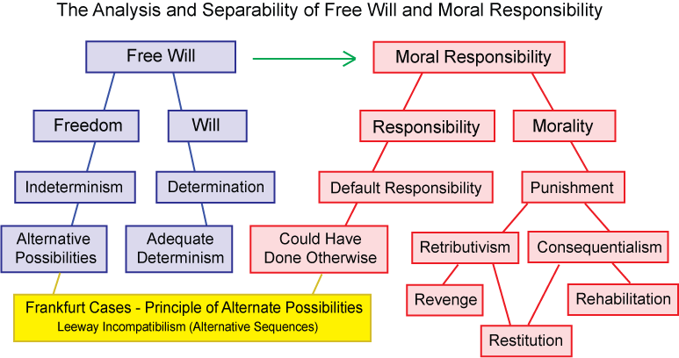
The Four Degrees of Separation:
- The Separation of "Free" from "Will"
- The Separation of "Responsibility" from "Moral Responsibility"
- The Separation of "Free Will" from "Moral Responsibility"
- The Separation of "Free Will and Moral Responsibility" from "Punishment"
From its earliest beginnings, the problem of "free will" has been intimately connected with the question of moral responsibility. Most ancient and modern thinkers on the problem have been trying to show that we humans have control over our decisions, that our actions "depend on us", and that they are not pre-determined by fate, by arbitrary gods, by logical necessity, or by a physical causal determinism.
But there are good analytic reasons to separate free will from moral responsibility, at least since 1962 when Peter Strawson argued that whatever the deep metaphysical truth on the issues of determinism and free will, people would not give up talking about and feeling moral responsibility - praise and blame, guilt and pride, crime and punishment, gratitude, resentment, and forgiveness.
Philosophers have asked whether free will and moral responsibility are limited to humans, and at what age children suddenly become free. We can separately answer the question of freedom with a scientific answer. All animals have freedom of behavior. Their actions are not pre-determined, although many actions are adequately determined by genetic and environmental factors, by physical limitations and external circumstances, and, most importantly, by their intentions.
Moral responsibility is less a scientific question than it is a social and cultural question – what is right and wrong? It is not free will that is acquired in human development, it is the competence to reflect on one’s behavior in the light of social norms. It is moral responsibility that is acquired, not freedom.
The Separation of "Free" from "Will"
"Free Will" - in scare quotes - refers to the common but mistaken notion that the adjective "free" modifies the concept "will." In particular, it indicates that the element of chance, one of the two requirements for free will, is present in the determination of the will itself.
In two-stage models of free will, the randomness is limited to the generation of alternative possibilities in the first stage. The second stage of evaluation and decision is adequately determined.
The Separation of "Moral" from "Responsibility"

Responsibility for a willed action can be ascribed to an agent because the "adequately" determined will has started a new causal chain that includes the action and its foreseeable consequences. But responsibility is not the same as moral responsibility. It is merely a prerequisite for moral responsibility.
Responsibility is similar to accountability. Just as an action can be said to be a cause of its consequences, so the agent can be held accountable for the action. But different moral codes, which are the concern of ethicists, may have different degrees of moral responsibility for the same actions and its consequences.
The Separation of "Free Will" from "Moral Responsibility"
The question of the existence of "free will" is an empirical and factual question about the nature of the mind. It does not depend on the existence of "moral responsibility," which is a question for ethics.
John Martin Fischer says that some philosophers do not distinguish between freedom and moral responsibility. For such philosophers, "freedom" refers to whatever conditions are involved in choosing or acting in such a way as to be morally responsible. But moral decisions are not the only free decisions.
The Separation of "Free Will and Moral Responsibility" from “Punishment”
Liberal and humanitarian thinkers who see that much retributive punishment is cruel and unproductive should not try to argue that punishment is not "deserved" because free will does not exist.
They have excellent reasons for preferring rehabilitation and education to vengeance. And humane society long ago substituted restitution (“an eye for an eye”) for brutal revenge. The balance and fairness that justice demands for unacceptable behavior is properly described as one’s “deserts.”
Whether man - and higher animals too - have free will is an empirical scientific question. Whether they have moral responsibility is a social and cultural question.
When well-meaning thinkers conflate free will with moral responsibility, then use spurious arguments to deny free will in order to deny its equivalent, moral responsibility, for the sole purpose of eliminating punishment, it may very well be fine humanism, but it is poor philosophy, and terrible science.
Sources:
http://www.informationphilosopher.com/freedom/separability.html

