Where, and When, is Randomness Located?

The physical location of indeterminacy in the brain and the timing of chance mental events relative to the decision are the two most critical problems for any model of libertarian free will.

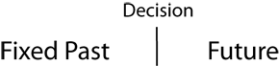

The two-stage model of free will expands the decision from a single point in time between the "fixed past" and the future. It becomes a two-stage process, first "free," then "will."
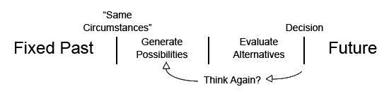
Note that the two-stage model explains how an agent can be in exactly the "same circumstances," and given the fixed past and the laws of nature, the agent can nevertheless act differently, that is to say, choose to do otherwise. This is because the decision is the end point of a temporal process that begins with those "same" circumstances. The decision-making process is not an instant in time.
Note also that the decision is not determined as soon as possibilities are generated and the alternatives evaluated. The agent may decide that none of the options is good enough and, time permitting, go back to "think again," to generate more possibilities.
The location and timing of chance as proposed by various philosophers can be displayed at three places in the temporal sequence of the two-stage model, including the "fixed past."
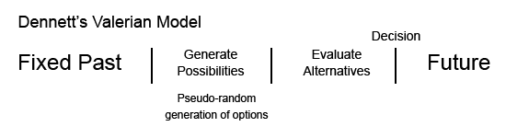
Dan Dennett's Valerian Model of decision making adds randomness in the first-stage generation of considerations, but he believes that pseudo-randomness (the kind generated by computer algorithms) is random enough.
Dennett sees no need for genuine irreducible quantum randomness in the mind, although he does not deny that the world contains genuine quantum indeterminacy. He also does not think, as does Jacques Monod, for example, that quantum indeterminacy is necessary for biological evolution. The evolved virtual creatures of artificial life programs demonstrate for Dennett that biological evolution is an algorithmic process.
Dennett says of the second stage that "after a certain amount of deliberation, I say to myself: 'That's enough. I've considered this matter enough and now I'm going to act,' in the full knowledge that I could have considered further, in the full knowledge that the eventualities may prove that I decided in error, but with the acceptance of responsibility in any case."
He says that "this model...provides some account of our important intuition that we are the authors of our moral decisions."
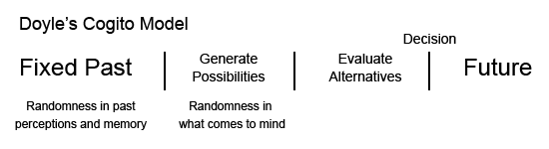
Bob Doyle's Cogito Model locates randomness not only in the generation of alternative possibilities, but also in past perceptions and imperfect memories that may have involved quantum indeterminacy.
The brain/mind is an information-processing system susceptible to quantum quantum and thermal noise. Errors are unavoidable in the recording and reproducing of experiences. These errors break the causal chain of pre-determinism back before an agent's birth. They are the source of novelty and creativity. They make us originators and authors of our lives.
The brain very likely also has access to "built-in" quantum randomness that it can turn on and off during the generation of possibilities. It has evolved to the quantum limit, able to see a single photon and smell a single molecule. So if the mind finds an advantage in quantum indeterminacy, it can recruit it when it proves useful, and suppress it when it's a problem.
This suggests that randomness might sometimes not be suppressed during the otherwise determinative evaluation of alternatives and final decisions. While very unlikely, such randomness might show up as occasional irrationality or "weakness of will." And of course, it would support Bob Kane's "torn decisions" and SFAs.

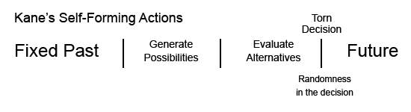
Bob Kane's Self-Forming Action (SFA) locates randomness (true quantum randomness) in the "torn decision" of an agent between multiple possible actions, each of which has excellent justifying reasons that allows the agent to take full moral responsibility for the choice, however the decision - randomly - comes out. He calls this "plural rational control."
Critics of any decision that is made randomly say that the agent has given up control, and consequently cannot be responsible. But Kane cleverly argues for exactly balanced and valid reasons for each action. There is a kind of liberty of indifference about the decision.
Kane says that if there was an imbalance in favor of one of the options, that would "determine" the decision. This would just be the standard two-stage model of Dennett, Doyle, and Mele, which Kane thinks is inadequate for a moral decision.
Kane distinguishes between moral decisions, prudential decisions (where strong interests are involved), and merely practical decisions. He accepts a two-stage model as sufficient for practical reasoning. But he argues that it is insufficient to establish the "ultimate responsibility" (UR) for moral and prudential decisions.
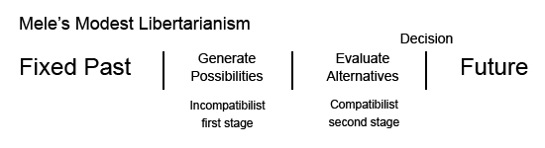
Al Mele's modest libertarianism provides what he calls an "incompatibilist" first stage (he means indeterminist) and a compatibilist second stage (he means determinist).
Mele does not (as does Kane? and many philosophers since a mistaken reading of R. E. Hobart's 1934 Mind article) think this determination of the will would imply pre-determinism.
Mele locates the randomness in the incompatibilist first stage of his two-stage model, where alternative possibilities are generated.
Mele's model is similar to Dennett's, but does not argue for pseudo-random (deterministic) randomness. However, because Mele is agnostic about the truth of determinism and indeterminism, he does not discuss the operation of quantum randomness explicitly.

