Libet’s Experiments and the Two-Stage Model
Benjamin Libet’s famous experiments are widely regarded as having established that conscious will is an illusion, starting with Libet’s own claim (mistaken, we shall argue) that the readiness potential he observed a few hundred milliseconds before the awareness of conscious will and the consequent muscle motion, was the cause of both the will and the action. Libet proposed that the will could nevertheless be free, if there was time for it to “veto” its own prior decision, which had been caused by the RP.
In 1978, Dan Dennett described a two-stage model for decision-making for a libertarian free will – a production stage with a random element, followed by a subsequent choice stage. The first stage generates alternative possibilities for action. In the second stage, the agent evaluates the options and chooses one based on reasons, motives, feelings, etc, consistent with character, values, etc.
The first stage involves randomness. It is at least the “stochastic” randomness described by Anthony Cashmore, Christoph Koch, and by Martin Heisenberg in Nature last year. They all note that this randomness is seen in the behavioral freedom of lower animals like fruit flies (Drosophila), and even prokaryotes like E. Coli bacteria. Heisenberg argues that this two-stage behavioral freedom - randomness followed by lawlike behaviors - evolved to become free will in higher animals and humans.
As early as 1884, William James proposed such a model, based on the analogy he saw with the two steps of Darwinian evolution, first random variations in the gene pool (known today to be quantum-mechanical accidental mutations of the DNA structure), followed by natural selection.
The first stage randomness might also include some irreducible quantum indeterminism, which would break the chain of classical determinism back to the Big Bang. Now virtually every philosopher and scientist who has considered the subject (with the dramatic exception of Robert Kane), considers quantum indeterminism of no use at all in the second, evaluation and decisions, stage. It would make the decisions random.
Note that the source of quantum “noise” need not be internal to the mind. It might be some random events coming from the environment or from other persons. Note also that the quantum randomness need not be contemporaneous with the current decision. It might be a random thought from long ago that lingers in the mind as an option. And finally, note that quantum noise in the brain itself may have various causes - errors of perception, mistakes in storage of ideas in memory (especially during nightly memory consolidation), or faulty recovery of an idea when it is recalled. All of these are the unavoidable errors that result from noise in any information-processing system, whether the read/write errors of a digital computer or flaws in the operation of a biological mind.
I like to separate the term “free will” into two distinct concepts, corresponding to the temporal sequence in Dennett’s two stages. First “free,” then ”will.” First chance, then choice.
Our thoughts come to us freely. Our actions go from us willfully.
Now let’s return to the Libet experiments and see how the two-stage model can restore free will, both conscious and unconscious will, by comparing the two temporal sequences.
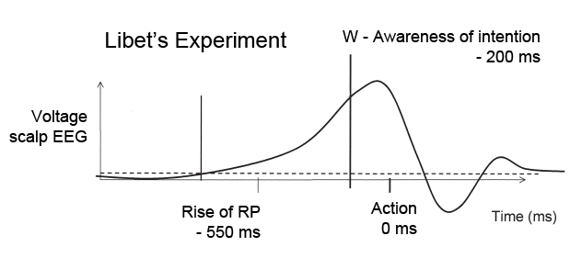
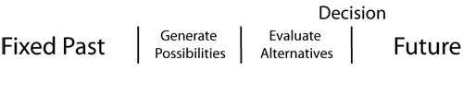
Although the abrupt and rapid decisions to flex a finger measured by Libet bear little resemblance to the kinds of two-stage deliberate decisions needed for responsibility, it seems reasonable to assume that neuronal activity might arise as the mind considers whether to flex or not to flex, when it forms the intention to flex. Roderick Chisholm argued that at least one alternative possibility always exists, we can always say no.
Libet, Haggard, Wegner, Koch and the others who say the conscious will does not cause the action, because your neurons have already made the decision, cannot prove a causal relation between RP and action. They are begging the question, assuming that a deterministic relation exists between the early stage RP and the action simply because it shows up earlier than the action (post hoc, propter hoc).
What if the early RP is just the first stage of developing options, followed by evaluating them, then deciding? In such an arbitrary choice - to flex or not flex, we should expect to see the readiness potential ossasionally rise up, but then not be followed by the W point and no muscle motion. The fact that Libet reports none of these lends weight to the idea that RP and muscle motion are indeed causally related. But this is a mistake, as pointed out by Alfred Mele.
All the Libet experiments work by storing the last few seconds of data that have been collected, triggered by detecting the wrist flex itself. The equally likely cases of a rise in RP followed by no wrist flex have been systematically ignored by Libet.
This missing data would establish there is no causal connection between RP and action, only between RP and considering the alternate possibilitiies, to flex or not to flex, in the two-stage model of free will.

