The Two-Step Process That Creates Information Structures in the Universe Also Creates the Ideas in Our Minds

By Bob (Robert O.) Doyle, rodoyle@fas.harvard.edu, Associate, Astronomy Department, Harvard University

A paper prepared for a special issue of Physics of Life Review on the Physics of Mind

Abstract:

We trace the creation of information structures in the universe from the appearance of elementary particles in the first few minutes through the creation and evolution of the galaxies, stars, and planets that began four hundred million years after the origin. All these cosmological information structures are passive, under the control of fundamental physical forces like gravitation, electromagnetism, and the nuclear strong and weak force. Information, per se, is not involved in their creation.

With the emergence of life on Earth, relatively soon after the formation of the Sun, active information structures appeared, which we define as structures using information processing and communication to manage the flow of matter and energy through themselves. Active information structures introduced agency and the appearance of purpose.

From the tiny molecular machines that are the active components of our cells (for example, ATP synthase, the ion pumps in our neurons, the flagella, ribosomes and their chaperones, and the central dogma of DNA > RNA > Protein) up to the thinking human mind, we trace an evolutionary development that depended at every stage 1) on quantum physics as the generator of new possibilities and 2) the radiation away from the new structure of the excess positive entropy, without which the new information (negative entropy) could not survive.

As Claude Shannon has shown, the creation of new information requires alternative possibilities. In a deterministic world, information would be a conserved constant, like the conservation of matter and energy. Information is immaterial. It is neither matter nor energy, and it is not conserved, although it needs matter for its (temporary) embodiment and energy for its communication, for example to other minds or for storage in the external environment.

Despite the physical basis for our work, from cosmology through biology to neuroscience, we strongly argue against current “physicalist” theories in the philosophy of mind, in which chemistry is reduced to physics, biology to chemistry, and the mind/brain reduced to biology.

We attack neurobiological reductionism and strictly determined “bottom-up causation.” At the same time, perhaps counter-intuitively, we defend a supervenient statistical “downward causation” that allows free thoughts (mental events that are not pre-determined) to cause willed actions. Actions are ultimately statistical but “adequately determined” by our motives, reasons, intentions, desires, and feelings, in short, by our character. We offer a two-stage model of free will, one initially seen in the nineteenth century by WiIliam James.

We defend an emergent dualism of mind and matter, subject and object, idealism and materialism. Monists might like the idea that information is a neutral quantity that can ground a triple-aspect monism of matter, life, and mind. Information itself is an emergent that did not exist in the early universe. We will show that information structures emerge in three ways and in a temporal sequence, corresponding respectively to matter, life, and mind.
First is the emergence of "order out of chaos" This has given rise to complexity and chaos theories that try to explain life as a "complex adaptive system." Ilya Prigogine won a Nobel prize for far-from-equilibrium "dissipative" processes that produce information structures, like Bénard convection cells. He called it "order out of chaos." These "complex" systems have no internal information processing. They are "dumb" structures. They do, however, exert a gross "downward causation" over their physical parts.
Second is the emergence of "order out of order." Erwin Schrödinger showed that all life feeds on a stream of negative entropy from the sun. He called this "order out of order." Biological processes rearrange the information in the negative entropy to create and maintain themselves. They are "information-processing systems." Their downward causation is extremely fine, meaning they can exert causal control over component atoms and molecules individually.
Third is the emergence of "pure information out of order." Abstract information is the "stuff of thought." It is the lingua franca, the currency, the coin of the philosophical realm. Mental processes create and store abstract information in the brain hardware. At the neuron level, atoms and molecules are exquisitely controlled by neurobiology to enable nerve firings and to record (and play back) information.
The core of our informational theory of mind is an experience recorder and reproducer. The ERR stores information in our neural networks about all the perceptual elements (sight, sound, touch, taste, smell) of an experience, along with our emotions during the experience. They are stored in whatever neurons fire together. Later, any new perceptual element that fires the same (or nearby) neurons can activate the neural network to replay the original experience, complete with its emotional content. The unconscious mind is a "blooming, buzzing confusion" of these reproduced experiences, to some of which we focus our attention. We identify four evolutionary stages in the development of an experience recorder and reproducer that exhibits consciousness.

- Introduction
Information philosophy (including information physics and biology) has identified the two steps in the process needed to create any new information structure, from those in the early universe to the information structures in biology to those in human minds.
1. The Quantum Step. Whenever matter is rearranged to create a new information structure, the quantum binding forces involve a collapse of the wave function that introduces an element of chance. Without subsequent alternative possibilities, no new information is possible.
2) The Thermodynamic Step. Any new information structure reduces the local entropy. It cannot be stable unless it transfers away enough positive entropy to satisfy the second law of thermodynamics, which says that the global, overall total entropy (disorder) must always increase.
In general, most new structures are short-lived and rapidly destroyed. The long-term stability of information structures ultimately depends on the expansion of the universe, which both cools the matter and energy and opens up more phase-space cells for possible new arrangements of material particles.
- Creation and Development of the Universe (Creation Without a Creator?)
We can divide the origin and evolution of the universe into two epochs, one from the first few minutes of elementary particle formation to the appearance of atoms about 380,000 years later.
Epoch 1 begins with extraordinarily high temperature and density. The temperature is falling and density of matter and energy is decreasing because the universe is expanding. Quarks are packed tightly as independent particles in pre-hadronic matter until the temperature is low enough for them to be frozen out, bound into hadrons (protons, neutrons). During much of this epoch the global entropy (disorder, chaos), is near its maximum, but it is very low compared to what it will become. And the transition into hadrons is the first formation of relative negative entropy objects, the first assembled information structures.
The next important development is when the high-entropy free electron gas starts to bind with protons into the earliest atoms. The free-electron gas was optically thick to the photon gas at temperatures above several thousand degrees, with an extremely short mean free path between (Compton) scatterings of photons by the electrons.
The first atoms did not become long-lived stable entities until at least 380,000 years after the origin of the universe when the temperature was about 5000K.
In the first few hundred thousand years of early universe, when matter was a very hot ionized plasma gas, an occasional electron combined with a proton to form a hydrogen atom. In a quantum transition from an unbound quantum state to a bound electronic state, the new atom radiated away the binding energy as a photon, - the electron's wave function collapsed into one of the possible bound states.
But immediately, a photon in the hot radiation field re-ionized the new atom. The information in that new atomic structure could not last until the universe had cooled down enough to become transparent to radiation. Once the universe became transparent, the radiation could carry away the positive entropy needed to satisfy the second law of thermodynamics globally since the atomic information structures left behind were pockets of local negative entropy.
We see those escaping photons, coming today in all directions from the cosmic microwave background radiation, cooled from 5000K to less than a few degrees Kelvin today..
Epoch 2. A similar two-step process is needed to form the galaxies, stars, and planets, which were starting to form about 400 million years after the origin. When gravitational forces attract huge volumes of matter, the matter heats up as it collapses. If a gravitating object could not radiate away that heat, it could not become a new information structure like a star or galaxy.
The space between the forming galaxies, into which positive entropy can be radiated, is provided by the expansion of the universe. Without the expansion, no new information would be possible in the universe.
To be sure, quantum chance plays little or no role in gravitational structures. The force of gravity is overwhelmingly deterministic.
All these cosmic information structures are informationally passive. Their interactions follow simple laws of "bottom-up reductionist physics.
Information philosophy focuses on the qualitatively valuable information structures in the universe. The destructive forces are entropic, they increase entropy and disorder. Creative forces are anti-entropic. They increase the order and information. We call them ergodic.
By information we mean a quantity that can be understood mathematically and physically. It corresponds to the common-sense meaning of information, in the sense of communicating or informing. It also corresponds to the information stored in books and computers. But it also measures the information in any physical object, like a stone or a snowflake, in a production process like a recipe or formula, and the information in biological systems, including cell and organ structures and the genetic code.
Information is mathematically related to the measure of disorder known as the thermodynamic quantity called "entropy." Ludwig Boltzmann derived a famous formula S = k log W, where S is the entropy and W is the probability - the number of ways that the internal components (the matter and energy particles of the system) can be rearranged and still be the same system. Thus information is related to probability and possibilities for different arrangements of matter.
The information we mean is closely related to "negative entropy," the departure of a physical system from pure chaos, from "thermodynamic equilibrium."
"Negative entropy" is simply the difference between the maximum possible entropy (where all the particles in a physical system are in a maximum state of disorder, there is no visible structure) and the actual entropy.
In a state of thermodynamic equilibrium, there is only motion of the microscopic constituent particles ("the motion we call heat"). The existence of macroscopic information structures, such as the stars and planets, and their motions, is a departure from thermodynamic equilibrium. And that departure we call the "negative entropy."
The second law of thermodynamics says that the entropy (or disorder) of a closed physical system increases until it reaches a maximum, the state of thermodynamic equilibrium. It requires that the entropy of the universe is now and has always been increasing.
This established fact of increasing entropy led many scientists and philosophers to assume that the universe we have is "running down" to a "heat death." They thought that meant the universe must have begun in a very high state of information, since the second law requires that any organization or order is susceptible to decay. The information that remains today, in their view, has always been here. There is nothing new under their sun.
But the universe is not a closed system. It is in a dynamic state of expansion that is moving away from thermodynamic equilibrium faster than entropic processes can keep up. The maximum possible entropy is increasing much faster than the actual increase in entropy. The difference between the maximum possible entropy and the actual entropy is potential information, as shown by David Layzer.
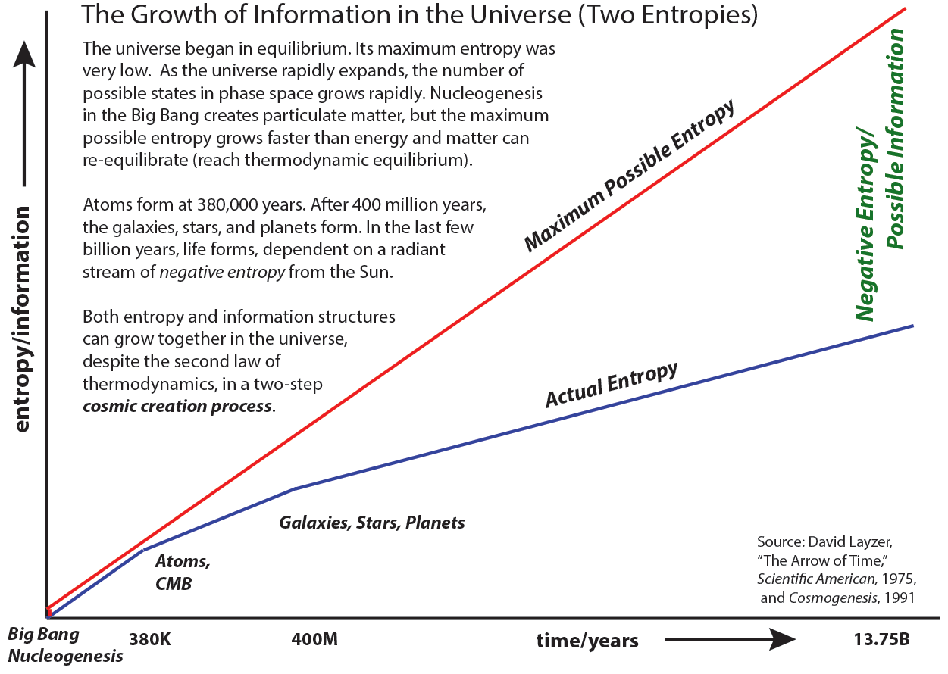

Creation of information structures means that in parts of the universe the local entropy is actually going down. Creation of a low entropy system is always accompanied by radiation of entropy away from the local structures to distant parts of the universe, into the night sky for example.
As the universe expands (see the figure), both positive and negative entropy are generated. The normal thermodynamic entropy, known as the Boltzmann Entropy, is the large black arrow. The negative entropy, often called the Shannon Entropy, is a measure of the information content in the evolving universe.
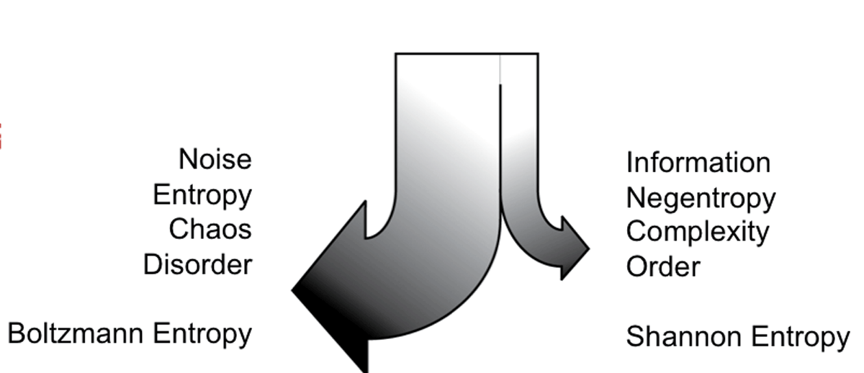
Entropy and information can thus increase at the same time in the expanding universe. There are generally two entropy/information flows. In any process, the positive entropy increase is always at least equal to, and generally orders of magnitude larger than, the negative entropy in any created information structures. Positive entropy must exceed negative, to satisfy the second law of thermodynamics, which says that overall entropy always increases.
Material particles are the first information structures to form in the universe.. They are quarks, baryons, and atomic nuclei, which will combine with electrons to form atoms and eventually molecules, when the temperature is low enough. These material particles are attracted together by the force of universal gravitation to form the gigantic information structures of the galaxies, stars, and planets.

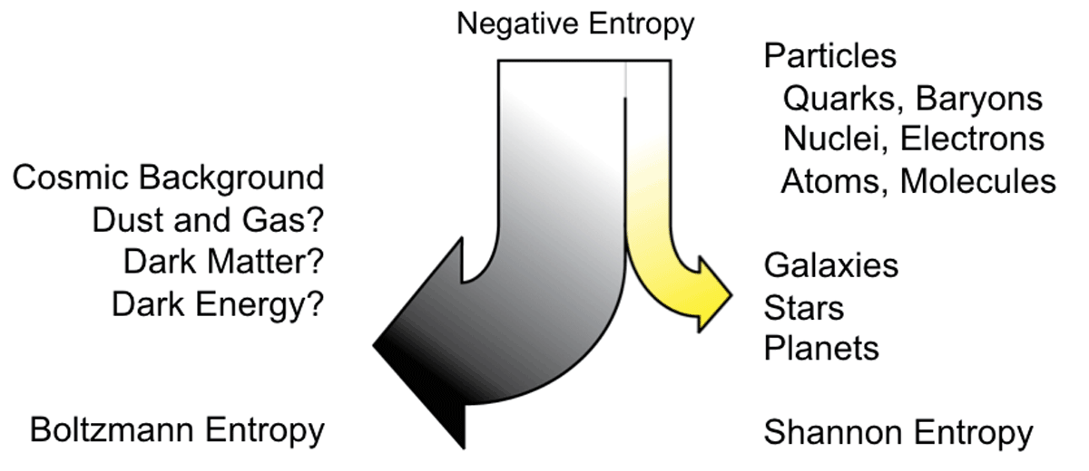

Microscopic quantum mechanical particles and huge self-gravitating systems are both stable and have extremely long lifetimes.
When stars form, they become another source of radiation after the original Big Bang cosmic source, which has cooled down to 3 degrees Kelvin (3K) and shines as the cosmic microwave background radiation.

- Origin and Evolution of Life (Evolution Without A Designer?)

Our solar radiation has a high color temperature (5780K) but a low energy-content temperature (273K). It is out of equilibrium and it is the source of all the information-generating negative entropy that drives biological evolution on the Earth.
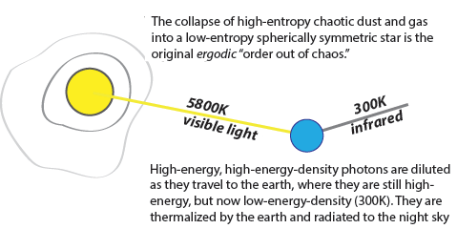

Note that the fraction of the Sun's light falling on Earth is less than a billionth of that which passes by and is lost in space.
A tiny fraction of the solar energy falling on the earth gets converted into the information structures of plants and animals. Most of it gets converted to heat and is radiated away as waste energy to the night sky.
Sadly, cosmic creation is horrendously wasteful. In the existential balance between the forces of destruction and the forces of creation, there is no contest. The dark side is overwhelming. By quantitative physical measures of matter and energy content, there is far more chaos than cosmos in our universe. But it is the cosmos that we prize, the information that we value.

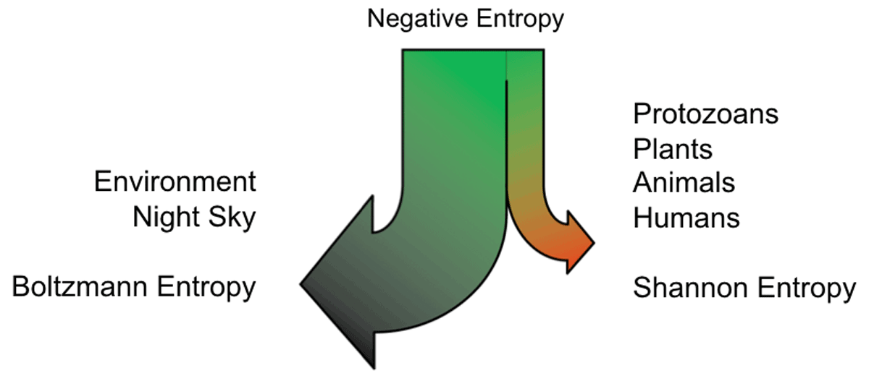

Every biological structure is a quantum mechanical structure. DNA has maintained its stable information structure (again, thanks to the extraordinary stability of quantum structures) over billions of years in the constant presence of chaos and noise.

- The Emergence of Mind (Mind Without An (Immortal) Soul?)

The stable information content of a human being survives many changes in the material content of the body during a person’s lifetime. Only with death does the mental information (spirit, soul, self, “ghost in the machine”) dissipate - unless it is saved somewhere outside the body, which we can consider a kind of “information immortality”.
The total mental information in a living human is orders of magnitude less than the information content and information processing rate of the body. But the information structures created by humans outside the body, in the form of external knowledge (we call them the Sum), including the enormous collection of human artifacts, rival the total biological information content.
Of all the problems that information philosophy may help to solve, few are more important than the question of Mind. There is little in philosophy that is more dehumanizing than the logic chopping and sophistical word juggling that denies the existence of Mind and Consciousness.
Some of the earliest philosophers, Plato for example, saw an immaterial Mind as the source of eternal truths about reality that could not be based on mere phenomena - unreliable sensations emanating from material bodies. The material world was thought to be a poor imitation of the Platonic “Ideas.”
Descartes' dualism reduced the bodies of all animals to living machines, but left room for a non-mechanistic, immaterial, and indeterministic Mind above and beyond the deterministic limits set by the laws of nature. Kant renamed the ancient division of sensible and intelligible worlds, locating God, freedom, and immortality in his noumenal world.
Information philosophy hopes to show that information is itself that immaterial “substance” above and beyond matter and energy that the ancients, Descartes, and Kant were looking for.
Information philosophy views the mind as the immaterial information in the brain. The brain is seen as a biological information processor. Mind is software in the brain’s hardware, although it is altogether different from the logic gates, bit storage, algorithms, computations, and input/output systems of the type of digital computer used as a "computational model of mind" by today's cognitive scientists.
The “stuff” of thought is pure information, neither matter nor energy, though it needs matter for its embodiment and energy for its communication. Information is the modern spirit, the soul in the body, the ghost in the machine.
In ancient philosophy, mind/soul versus body was one of the classic dualisms, such as idealism versus materialism, the problem of the one (monism) or the many (pluralism), the distinction between essence and existence, between universals and particulars, between necessity and contingency, between eternal and ephemeral, but most important, the difference between the intelligible world of the noumena and the ​sensible world of mere appearances or phenomena.
When mind and body are viewed today as a dualism, it is because the mind is considered to be fundamentally different from the material brain, though perhaps not another “substance.” We propose an easily understandable and critically important physical difference between matter and immaterial information. Whereas the total amount of matter is conserved, the universe is continuously creating new information - by rearranging existing matter into new information structures. The total amount of information (a kind of order) in the universe is increasing, despite the second law of thermodynamics, which - counterintuitively - says that the total amount of disorder (entropy) is also increasing.
Matter, along with energy (mc²), cannot increase. It is conserved, a constant of the universe. By contrast, information is not conserved. As information grows, it is the source of genuine novelty in the universe. The future is not determined by the past and present, because the future contains unpredictable new information. New information is continuously being created.
If mind and matter then are to be considered part of a dualism, it will not be a "material substance" dualism, but it can still be a "physical substance" dualism, since mind and matter are both physical and "substantial," in the sense of having real causal power. We recognize that something immaterial with causal power also fits the description of metaphysical.
With the appearance of life, purpose entered the universe. The fundamental purpose of all life is to survive, at least long enough to replicate. For most species, all of the information needed to survive is transmitted in the genes and the biological machinery of the cell. To benefit from the experiences of an ancestor, those experiences must somehow be encoded genetically, so they show up as a priori, built-in capabilities of the offspring. Konrad Lorenz said that what is a priori for an individual (ontogeny) was a posteriori for its ancestors (phylogeny).
The appearance of human minds marks the beginning of significant amounts of knowledge stored extra-biologically. Externally stored information (the "Sum") needed for human survival can be transmitted culturally between the generations. The development of the highest forms of philosophical and scientific thought would have been impossible without the externally stored information we call the Sum. Arguably, even language itself could not have developed. A child deprived of its senses for access to human culture would never speak. According to Merlin Donald, human culture did not develop because humans had acquired language to communicate. We developed language to improve on the primitive communication capabilities (miming, pointing, signing) of pre-linguistic humans.
Humans are conscious of our experiences because they are recorded in (and reproduced on demand from) the information structures in our brains. We call it the Experience Recorder and Reproducer (ERR). Mental information houses the content of an individual character - the fabric of values, desires, and reasons used to evaluate alternatives for action and thus to make meaningful choices. We see immaterial mental information as the location for our self, our soul, a spirit, a “ghost in the machine,” as Gilbert Ryle called it when he attacked mind as an illusion.
Sadly for some, our evidence for this immaterial soul gives us no evidence of its immortality.
The experience recorder and reproducer is an information model for the mind. The ERR is simpler than, but superior to, the computational models of the mind popular in today's neuroscience and cognitive science. It is the "software in the brain hardware."
Although we see mind as immaterial information, we think that man is not a machine and the mind is not a computer.
Our ERR mind model grows out of the biological question of what sort of "mind" would provide the greatest survival value for the lowest (or the first) organisms that evolved mind-like capabilities. It is not yet a model of the reasoning mind, as we shall see.
We propose that a minimal primitive mind would need only to "play back" past experiences that resemble any part of current experience. Remembering past experiences has obvious relevance (survival value) for an organism. But beyond survival value, the ERR touches on the philosophical problem of "meaning." We suggest the epistemological "meaning" of information perceived may be found in the past experiences that are reproduced by the ERR.
The ERR model is a memory model for long-term potentiation stored in the neocortical synapses. Short-term memory must have a much faster storage mechanism. While storage is slow, we shall see that ERR retrieval is just as fast, and it does not fade as does short-term, working memory.
We propose that the ERR reproduces the entire complex of the original sensations experienced, together with the emotional response to the original experience (pleasure, pain, fear, etc.). Playback of past experiences are stimulated by anything in the current experience that resembles something in the past experiences, in the five dimensions of the senses (sound, sight, touch, smell and taste).
The ERR model stands in contrast to the popular cognitive science or “computational” model of a mind as a digital computer with a "central processor" or even many "parallel processors." No algorithms or stored programs are needed for the ERR model. There is nothing comparable to logic gates or the addresses and data buses used to stored and retrieve information in a digital computer.
No modern computer can surpass the amazing information storage capability and rapidity of search and retrieval of information as that of the human neocortex. Unlike most of the brain, the neocortex randomly grows its over 10 billion axons, each with 10,000 dendritic connections. The neocortex takes over twenty years to form completely, and over a human lifetime much of it will be pruned away by non-use. Only those neurons that were fired by input sensations strengthen their synapses.
The biological basis for our proposed ERR is very straightforward.

- The ERR Recorder: Neurons become wired together (strengthening their synaptic connections to other neurons) during an organism’s experiences, across multiple sensory and limbic systems. The neuroscientist Donald Hebb said in 1949 that "neurons that fire together wire together."
- The ERR Reproducer: Later firing of even a part of the previously wired neurons can stimulate firing of all or part of the original complex, thus "playing back" similar past experiences (including the critically important emotionalreaction to those experiences). Extending Hebb’s insight, we now say simply that "neurons that have been wired together will fire together."
It is of course well-known that when a spot in the neocortex is stimulated electrically, experiences are reproduced.
The ERR model hypothesizes that for higher animals related experiences are likely stored "nearby" (in the many "dimensions" of visual cortex, hearing pathways, olfactory nerves, etc., etc., plus connections to the amygdala for emotions). In humans this may include the multiple connections from the amygdala into the prefrontal cortex, both the dorsolateral and ventromedial PFC that have been discovered to react to pleasure/pain differences and utility evaluations.
If similar experiences are short distances apart (since storage location is entirely determined by the "pattern" or "shape" of the experience in each sensory dimension), then thermal or quantum noise in the glia separating neurons may contribute a random element as to which experiences come to mind or "pop into our heads."
The ERR model might then nicely explain the philosophical notion of association of ideas. If it is neighboring neurons that fire, they will likely be closely related in some way (since they were stored based on the fundamental pattern of information coming in during an experience). Similar experiences are likely stored in adjacent neurons. Note that a particular smell could cause the recall of experiences where that smell was present, and similarly for other senses. Smell/taste may be the primitive senses of the smallest organisms, e.g., bacterial cells, that have been conserved in higher forms.
Although individual cells likely have nothing like pleasure and pain, we might see the bacterial cell's binary possibilities in a homologous relationship to the "fight or flight" reaction in higher animals.
Neuroscientists are investigating how diverse signals from multiple pathways can possibly be unified in the brain. The ERR model offers an extremely simple insight into this so-called “binding” problem. There is an intrinsic binding of the multiple sensory and limbic systems present in the original wiring or "recording" of a complex experience. So although one or more experiences may be stimulated to play back because of a new experience with even just a single sense, the "binding" of all the original senses and emotion in each experience is simply the result of the Hebbian "wiring" of neurons during the original experience
We assume that whenever a particular experience plays back, it refreshes and strengthens the synaptic connections. It might also be the case that the current conditions can modify the connections somewhat, both slightly modifying the memories of the experience and the emotions associated with the experience. ERR might then become an explanatory basis for conditioning experiments, classical Pavlovian and operant conditioning, and in general a model for associative learning.
The capability of reproducing experiences is critical to learning from past experiences, so as to make them guides for action in future experiences, and to provide the context needed for “meaning”. The ERR model is the minimal mind model that provides for such learning by living organisms. It is critical that the original emotions also play back, along with any differences from past emotions that are newly experienced during playback.
You might not normally notice the speed with which you can recall the name of a sixth-grade teacher or childhood friend that has not occurred to you for decades. Or that a few notes might bring back music and lyrics of a song not sung for many years. An odd smell might evoke memories of a foreign country. A taste might bring on feelings of nausea first experienced long ago. All the senses, not just visual stimulation, can replay complex, multi-sensory original events. How does it work so fast?
Sometimes when you consciously try to recall a particular name, it does not come immediately to mind, but you can feel it on "the tip of your tongue." Then hours, even days later the forgotten name just "pops into your head." It suggests unnoticeable "unconscious" information processing by the Experience Recorder and Reproducer.
To make a crude estimate of the speed and power of the brain as a biological information processor, we can calculate the information creation going on in the body overall. Estimating how much power the body consumes (metabolizing of food as negative entropy), we can then use the fact that the brain uses about 20 percent of that energy.
We can take just one bodily process that is also vital to thought, the continuous replacement of red blood cells, which consumes a significant fraction of available energy. When 200 million of the 25 trillion red blood cells in the human body die each second, 100 million new hemoglobins must be assembled in each of 200 million new blood cells . With the order of a few thousand bytes of information in each hemoglobin, this is 10 thousand x 100 million x 200 million = 2 x 10²⁰ bits of information per second, a million times more information processing than today's fastest computer CPU.
What is the brain doing with such immense power consumption and potential information generation. It could be the "blooming, buzzing, confusion" that William James imagined going on just below his "stream of consciousness."
How can the mind "focus attention," as James put it? Think of how the eye can instantly be drawn to a tiny dark speck moving in our peripheral vision.
The ERR's operation is nothing like the way a computer searches and retrieves information. ERR does not decide what to search for and then look systematically through all the information structures to find it.
We can compare Google's "distributed search" algorithms, which send a search phrase to hundreds of thousands of computers in centers around the world. After vast amounts of "parallel distributed processing," each computer returns its relevant pages within a fraction of a second. These are then assembled into the Google "results" pages. The ERR works nothing like that.
A more appropriate example would be today's natural language translation systems. For decades, computer engineers were convinced they could write algorithmic translation programs. They only needed to understand ("reverse engineer") Noam Chomsky's "deep grammar" that generates all possible language. The U.S. Department of Defense invested $20 million over twenty years before declaring machine translation (MT) a failure. Today machine translation systems use a database of known translation pairs in a giant database called translation memory (TM) to accomplish what is known as “statistical translation”.
The largest such TM systems use incredibly large databases gathered from bilingual pair sentences captured from translated articles on the Internet. They work something like our ERR.
Google Translate takes a sentence and searches for matches of all or part of the string of letters and retrieves matches, returning them ordered by the closeness of a match, to the translator.
So where machine translation is algorithmic and a failure, and the current statistical translation approach based on astounding amounts of "big data" is a reasonable success, we are tempted to say that storage of a vast amount of personal "big data" in the mind/brain gets closer to a plausible model for a mind. We do not know, but Google's search technology may store data at an address that is the data itself (so-called "content-addressable" data storage, in which the address bus is the data bus), making the search algorithm very simple.
By comparison in the ERR, the current experience travels into the brain on neurons which process it in the normal way for storage, based on its analysis (breakdown) of the multi-sensory content of the image. This seems similar to "content-addressing." The sensations travel into the neocortex, processed by the various visual areas, auditory areas, etc., all connected through the association areas, based solely on the information content. Our hypothesis is simply that similar data will then be stored in similar areas.
Neurons that start firing will stimulate those previously wired together and others nearby to fire, reproducing a vast number of past real (and perhaps imaginary) experiences that were (at least partially) recorded to the newly firing neurons. Presented with an experience, the action potentials moving through the forest of axons and dendritic connections start nearby neurons firing which are experienced (we assume mostly unconsciously) just as if a past experience is happening again.
Since the number of reproduced experiences could be huge, it may sound absurd to suggest that the mind can pick out anything useful from such a cacophony. William James did describe what he called “a blooming, buzzing confusion.” But it is precisely all the past similar experiences retrieved that provide the context for the current experience to be "meaningful." If there were nothing played back, like the infant brain, there would be no "meaning" in the experience. In the adult mind, a lifetime of experience is available, usually instantly played back unconsciously, without us ever having to consciously ask for it.
We can say that "what it's like to be" a certain animal depends entirely on what its ERR chooses to record and reproduce. A frog, for example, famously allows only the signals from certain shapes to go beyond the frog's eye to its brain. In our ERR model, the frog has no experience recorded of concave-shaped objects moving in its visual field. Such information then is literally "meaningless."
Consciousness can be defined in information terms as a property of an entity (usually a living thing but we can also include artificially conscious machines or computers) that reacts appropriately to the information (and particularly to changes in the information) in its environment.
In the context of information philosophy, the Experience Recorder and Reproducer can provide us with what we can define as information consciousness.
An animal in a deep sleep is not conscious because it ignores changes in its environment. By contrast, an inanimate robot may be conscious in our sense. Even the lowliest control system using negative feedback (a thermostat, for example) is in a minimal sense conscious of (aware of, exchanging information about) changes in its environment.
This definition of consciousness fits with our model of the mind as an experience recorder and reproducer (ERR). Can we say that an organism is "unconscious" If no past experiences are playing back during its current experiences? Can we say that a frog is "not conscious" of the concave objects flying by?
A conscious being is constantly recording information about its perceptions of the external world, and most importantly for ERR, it is simultaneously recording its feelings. Sensory data such as sights, sounds, smells, tastes, and tactile sensations are recorded in a sequence along with pleasure and pain states, fear and comfort levels, etc. We sometimes speak of a "heightened" consciousness that excels at this recording.
All these experiential and emotional data are recorded in association with one another. This means that when the experiences are reproduced (played back in a temporal sequence), the accompanying emotions are once again felt, in synchronization. Although past experiences played back internally are not the same as the current external, they can make us currently "conscious" of past pleasure and pain states, fear and comfort levels, and so forth.
Bernard Baars's Global Workspace Theory uses the metaphor of a "Theater of Consciousness," in which there is an audience of purposeful agents calling for the attention of the executive on stage.
In the ERR parallel, vast numbers of past experiences are clamoring for the attention of the conscious mind at all times, whenever anything in current experience has some resemblance to past experiences.
If we define "current experience" as all afferent perceptions plus the current contents of consciousness itself, we get a dynamic self-referential system with plenty of opportunities for negative and positive feedback.
The "Blackboard model" of Allan Newell and Herbert Simon imagines pictures or words (concepts, say) being written on a mental blackboard by our current perceptions. Deep memory structures are watching what is written on the blackboard. They call up similar concepts by association and write them to the blackboard, which is visible to our conscious mind selecting the next things to think about. The ERR model clearly supports this view and explains the neural mechanism by which concepts (past experiences) are retrieved and come to the blackboard.
In Daniel Dennett's consciousness model, the mind is made up of innumerable functional homunculi, each with its own goals and purposes.
Some of these homunculi are information structures in the genes, which transmit "learning" or "knowledge" from generation to generation by heredity alone. Others are environmentally and socially conditioned, or consciously learned through cultural transmission of information, parents and teachers educating our young.
We can identify four evolutionary stages in the development of the Experience Recorder and Reproducer.

Instinct. These animals with little or no learning capability. The ERR in such animals does no recording. Reactions to environmental conditions have been transmitted genetically. Information about past experiences (by prior generations of the organism) is is "built in" as inherited reactions.
Learning. Here past experiences of animals guide their current choices. Conscious, but mostly habitual, reactions are developed through recorded experiences, including instruction by parents and peers.
Prediction. - The Sequencer in the ERR system can play back beyond the current situation, allowing the organism to use imagination and foresight to evaluate the future consequences of its choices.
Reflection. Here conscious deliberation about values influences the choice of behaviors. The ERR plays back a range of similar experiences including the reactions and feelings expressed by others to those experiences.
All four levels are emergent, in the sense that they did not exist in the lower, earlier levels of biological evolution.
Even the most primitive of biological systems are cognitive, in the sense that they use their internal information structure to guide their actions. Some of the simplest organisms can learn from experience. The most primitive minds are the earliest experience recorders. They reproduce past experiences as alternative possibilities for current actions.
In humans, the information-processing structures create new actionable information (knowledge) by consciously and unconsciously reworking the experiences stored in the mind.
Emergent higher mental levels exert downward causation on the contents of the lower bodily levels, ultimately supporting mental causation and free will.

.

- Philosophy of Mind (Emergence, not Reductionism)

The problem of mental causation depends heavily on the idea of “causal closure” of the world under deterministic laws of nature. The central issue in the classic mind-body problem is how an immaterial mind can move a material body if the “causal chains” are limited to interactions between physical things.

We propose a model or theory of mind as the pure information in the biological information-processing system that is the brain and central nervous system. We show how this model can support a non-reductive physicalism. Information is physical, but immaterial. Quantum physics produces breaks in the “causal chains” that have been used to “reduce” biological phenomena to physics and chemistry and mental events to neural events.

We argue against neurobiological reductionism and “bottom-up causation.” At the same time, we defend a supervenient “downward causation” that allows free thoughts to cause willed actions, actions that are ultimately “adequately determined” by our motives, reasons, intentions, desires, and feelings, in short, by our character.

Quantum mechanical events have generally been thought to be unhelpful by philosophers of mind. Adding indeterminism to mental events apparently would only make our actions random and our desires the product of pure chance. If our willed actions are not determined by anything, they say, we are neither morally responsible nor truly free. Whether mental events are reducible to physical events, or whether mental events can be physical events without such reduction, the interposition of indeterministic quantum processes apparently adds no explanatory power. And of course if mental events are epiphenomenal, they are not causally related to bodily actions. Even if epiphenomena had access to quantum physics, they could not affect the body.

Some philosophers of mind (e.g., John Searle David Chalmers Christoph Koch?) have considered the “mystery” of quantum indeterminism as potentially relevant to philosophy of mind, for example specifically to the problem of consciousness, because it too is a “mystery. “

Our challenge is to admit some quantum indeterminism into a “statistical” causality - an indeterminism which renders our mental causes merely “statistical” - yet nevertheless allow us to describe mental causes as “adequately determined.” That is to say, mental causes are essentially - and for all practical purposes - “determined,” because the statistics in most cases are near to certainty. And more importantly, our thoughts - and subsequent actions – are in no way completely “pre-determined,” neither from causal chains that go back before our birth such as our genetic inheritance, nor from the immediate events in the “fixed past,” which together with assumed deterministic “laws of nature,” are thought by compatibilists to completely explain our actions.

We propose a model of non-reductive physicalism that treats the mind as physical, but nevertheless immaterial. Specifically, we identify the mind as the information in a brain. We regard the brain and central nervous system as a biological information-processing system, one that has very little in common with the computational brain models of today’s cognitive science.

We show how quantum physics can break critically located links in the “causal chains” that have historically been used by philosophers of mind to argue for “bottom-up” causation. Breaking these deterministic links means that the properties of molecules cannot be reduced to those of atoms, the properties of biological cells cannot be reduced to those of molecules, those of plants and animals cannot be reduced to those of cells, and the mind cannot be reduced to neurons in the brain.

We make the case for specific “emergent” properties at those higher hierarchical levels that could not have been predicted from the laws of lower levels. We then defend an emergent capability for “downward causation,” in which biological systems have limited causal powers over their component atoms and molecules, and at the highest level we show how the mind can exert a supervenient downward causation on the brain, which is needed for the body to act willfully, adequately determined by the agent’s motives, reasons, feelings, intentions, and desires.

And we show that determinism itself is an emergent property. Determinism shows up only when we can average over a large enough number of atoms and molecules so that indeterministic events are statistically insignificant. Since this kind of determinism is only highly probable, and not perfectly certain, we call it “adequate” determinism.

The leading defender of a non-reductive physicalism was Donald Davidson. Its leading critic is Jaegwon Kim. In his 1970 essay "Mental Events," Davidson described his "Anomalous Monism":

Mental events such as perceivings, rememberings, decisions, and actions resist capture in the nomological net of physical theory. How can this fact be reconciled with the causal role of mental events in the physical world? Reconciling freedom with causal determinism is a special case of the problem if we suppose that causal determinism entails capture in, and freedom requires escape from, the nomological net. But the broader issue can remain alive even for someone who believes a correct analysis of free action reveals no conflict with determinism. Autonomy (freedom, self-rule) may or may not clash with determinism; anomaly (failure to fall under a law) is, it would seem, another matter.

In order to allow mental events to cause physical events, yet not be reducible to them, Davidson developed the following set of arguments.

- "at least some mental events interact causally with physical events"
- "where there is causality, there must be a law: events related as cause and effect fall under strict deterministic laws."
- "there are no strict deterministic laws on the basis of which mental events can be predicted and explained." (mental events are "anomalous.")

Davidson viewed his work as extending that of Immanuel Kant on reconciling (eliminating the anomalous contradiction between) freedom and necessity.
Davidson gave the term supervenience a specific philosophical meaning within analytic philosophy. He saw supervenience as the last hope for a non-reductive physicalism, which does not reduce the mental to the physical, the psychological to the neurophysiological.

Davidson set two requirements for supervenience:

- a domain can be supervenient on another without being reducible to it (non reduction)
- if a domain supervenes, it must be dependent on and be determined by the subvenient domain (dependence)

In Jaegwon Kim's 1989 presidential address to the American Philosophical Association, he said:

The fact is that under Davidson's anomalous monism, mentality does no causal work. Remember: in anomalous monism, events are causes only as they instantiate physical laws, and this means that an event's mental properties make no causal difference.

Kim claims that:

“The most fundamental tenet of physicalism concerns the ontology of the world. It claims that the content of the world is wholly exhausted by matter. Material things are all the things that there are; there is nothing inside the spacetime world that isn't material, and of course there is nothing outside it either. The spacetime world is the whole world, and material things, bits of matter and complex structures made up of bits of matter, are its only inhabitants. “

Kim says that Davidson's goal of "non-reductive physicalism" is simply not possible. The physical world is "causally closed," says Kim:

“what options are there if we set aside the physicalist picture? … This means that one would be embracing an ontology that posits entities other than material substances — that is, immaterial minds, or souls, outside physical space, with immaterial, nonphysical properties.”

We accept part of Kim's criticism. An informational theory of mind posits the existence of something immaterial, yet physical. It is both a “non-reductive physicalism” and an “immaterial physicalism.” But it is not "outside space and time" in some Kantian sense. Although it may contain something of what believers in souls thought they believed in.
The germ of the idea was apparent in a series of papers in the 1950’s and 1960’s by Hilary Putnam and Jerry Fodor, whose theory of functionalism pointed to characteristics of mind that are “multiply realizable” in different physical substrates. They were inspired by the then new digital computers, whose software could be moved between different computers and perform the same functions. Mind is the software in the brain hardware, they argued.

Our informational theory of mind shows how thoughts that are embodied in one mind can be converted from their material instantiation and transformed into the pure energy of sound waves or electromagnetic waves by which they are communicated to other minds, there to be embodied again. During communication, knowledge is not material, though it is still a part of the physical world.
In 1976 Kenneth Sayre proposed that information might be a neutral category in which concepts of mind and concepts of body might be defined. We agree that information might be the basis for a neutral, triple aspect, monism.
The informational analysis of non-reductive physicalism must show exactly how information does not move in the upward direction between hierarchical levels (fundamentally because noise in the lower level makes motions incoherent), but that information does move down as the higher-level information-processing system uses it to manipulate individual physical particles (maintaining a high signal-to-noise ratio in the upper level), as the British empiricists imagined.

Although the concept of emergence has become very popular in the last few decades in connection with the development of chaos and complexity theories (which, as we saw, support only a "gross" form of downward causation), emergence is actually a very old idea, dating at least to the nineteenth century, with some hints of it in ancient and medieval philosophy.
The idea of emergence was implicit in the work of John Stuart Mill and explicit in "emergentists" like George Henry Lewes, Samuel Alexander, C. Lloyd Morgan, and C. D. Broad. Brian McLaughlin dubbed these thinkers the "British Emergentists." He developed an "idealized" version of British Emergentism and synthesisized what most of these thinkers had in common into a coherent and representative picture. He says:
British Emergentism maintains that everything is made of matter: There are, for example, no Cartesian souls, or entelechies, vital elan, or the like. And it holds that matter is grainy, rather than continuous; indeed, that it bottoms-out into elementary material particles, atoms or more fundamental particles...Moreover, on its view, nothing happens, no change occurs, without some motion of elementary particles. And all motion is to the beat of the laws of mechanics.
According to British Emergentism, there is a hierarchy of levels of organizational complexity of material particles that includes, in ascending order, the strictly physical, the chemical, the biological, and the psychological level. There are certain kinds of material substances specific to each level. And the kinds of each level are wholly composed of kinds of lower levels, ultimately of kinds of elementary material particles. Moreover, there are certain properties specific to the kinds of substances of a given level. These are the "special properties" of matter...
What is especially striking about British Emergentism, however, is its view about the causal structure of reality. I turn to that view in the following two paragraphs.
British Emergentism maintains that some special science kinds from each special science can be wholly composed of types of structures of material particles that endow the kinds in question with fundamental causal powers. Subtleties aside, the powers in question "emerge" from the types of structures in question...
Now, the exercise of the causal powers in question will involve the production of movements of various kinds. Indeed, Emergentism maintains that special kinds, in virtue of possessing certain types of minute internal structures, have the power to influence motion. And here is the striking point: They endow the kinds with the power to influence motion in ways unanticipated by laws governing less complex kinds and conditions concerning the arrangements of particles. Emergentism is committed to the nomological possibility of what has been called "downward causation".
Minute internal (information-processing) structures that control the motions and arrangements of the component particles is the signature aspect of British Emergentism, one that we have demonstrated with ribosomal control of the twenty kinds of amino acids in living systems and ion channel control over the ions two and three at a time in the brain's neural network.
European vitalists like Henri Bergson and Hans Driesch may not have used the term emergence, but they strongly supported the idea of teleological (purposeful), likely non-physical causes, without which they thought that life and mind could not have emerged from physical matter.
Bergson attacked the idea that the "reversibility" of physical systems can be applied to living things. Reversibility was popular in the late nineteenth century as a criticism of the second law of thermodynamics, especially the derivation of this law from statistical mechanics by Ludwig Boltzmann. The laws of Newtonian mechanics are time reversible. Atoms and molecules have no memory of their past. Living systems, however, gain something from their memory of the past.
Driesch was an anti-mechanist who developed a sophisticated form of vitalism that he called "neovitalism."
Driesch saw clear evidence of a kind of teleology in the ability of lower organisms to rebuild their lost limbs and other vital parts. He used Aristotle's term "entelechy" (loosely translated as "having the final cause in") to describe the organism's capacity to rebuild. Driesch said this disproved the theory of preformation from an original cell. Driesch studied the original cells of a sea urchin, after they had divided into two cells, then four, then eight. At each of these stages, Driesch separated out single cells and found that the separated cells went on to develop into complete organisms. This is regarded as the first example of biological cloning.
British empiricits, notably C. D. Broad, rejected Driesch's idea of entelechy as a non-material, non-spatial agent that is neither energy nor a material substance of a special kind, but we should note that it well describes the information content of any cell that lets it develop into a complete organism. Driesch himself maintained that his entelechy theory was something very different from the substance dualism of older vitalisms. So what was Broad's criticism of Driesch? Neither thinker could produce a clear description of their vital element.
Broad was sophisticated in his discussion of emergence. He saw that the kind of emergence that leads to water and its unique chemical properties, when compared to the properties of its molecular components hydrogen and oxygen, has no element of purpose or teleology. The emergence of life (and mind) from physics and chemistry, however, clearly introduces a kind of design or purpose. Modern biologists call it teleonomy, to distinguish it from a metaphysical telos that pre-exists the organism. Jacob's "The goal of every cell is to become two cells."
It seems likely that both Driesch and Broad were trying to grasp this teleonomy.
A number of later "holistic" thinkers gathered for the 1968 Alpbach Symposium organized by Arthur Koestler, which he published as the book Beyond Reductionism. They included Ludwig von Bertalanffy (who had in the 1930's anticipated some of the later work of Erwin Schrödinger and Ilya Prigogine), Paul Weiss, Jerome Bruner, Viktor Frankl, Friedrich Hayek, Jean Piaget, and C. H. Waddington, who mostly thought it likely that further emergent hierarchical levels "over and above" the molecular level would be needed to fully explain biology, and that these levels were unlikely to be deterministic.
We have demonstrated biological and neurological evidence supporting their anti-reductionist ideas of mental causation in particular and the more general problem of downward causation, for example the downward control of the motions of a cell's atoms and molecules by supervening on biological macromolecules. The molecular biology of a cell is not reducible to the laws governing the motions of its component molecules. But are there emergent laws governing motions at the cellular level, the organ level, the organism level, and so on up to the mental level?
If so, these are perhaps simply the laws of the "special sciences" that scientists identify to help them explain their discipline to one another, e.g., Mendel's laws of inheritance in biology, the Weber and Fechner laws of perception in physiology (the just noticeable difference and the logarithmic response to a stimulus), or the law of supply and demand in economics.
What then can we conclude about Jaegwon Kim's attack on the non-reductive physicalism dream of Donald Davidson? Among philosophers of mind, Kim is the standard bearer for a monistic physicalism. Every writer on emergent dualism has to confront his philosophical arguments.
The locus classicus of twentieth-century discussions of philosophy of mind and mental causation is Donald Davidson's 1970 essay "Mental Events," which was revisited in his 1993 essay, "Thinking Causes," published together with 15 critical essays on Davidson's work in the 1993 book Mental Causation, edited by John Heil and Alfred Mele.
What can we then make of Jaegwon Kim’s assertion that "non-reductive physicalism" is simply not possible, that the physical world is "causally closed?" Recall Kim’s view:
“what options are there if we set aside the physicalist picture? Leaving physicalism behind is to abandon ontological physicalism, the view that bits of matter and their aggregates in space-time exhaust the contents of the world. This means that one would be embracing an ontology that posits entities other than material substances — that is, immaterial minds, or souls, outside physical space, with immaterial, nonphysical properties.”
We find the idea of causal closure is a mistake. Quantum physics and the second law of thermodynamics show us that the physical world is not causally closed. The expansion of the universe shows it to be physically and informationally open, otherwise the total amount of information in the universe would be conserved, a constant of nature, which some mathematically inclined philosophers and scientists appear to believe (Roger Penrose and Michael Lockwood, for example).
Jaegwon Kim may be wrong about causal closure, but he is correct that the ontology we embrace does picture the mind as immaterial. Although thoughts in the mind - Descartes’ “thinking substance” - are immaterial, that does not mean that they are “outside physical space.” Rather they are physically present in our brains in the same sense as mathematics is there, as all concepts and ideas are there. They are information, the software in the hardware.
As we saw above, Davidson made three causal claims for mental causation. They can now be adapted to the statistical causality allowed by quantum physics:
1. Mental events are statistically caused by physical events.
2. Causal relations are normally backed by statistical laws.
3. There are no strict deterministic laws for mental events acting on physical events. But statistical causality and adequate determinism are good enough.
Davidson's main goal was to deny the reducibility of mental events to physical events in the lower levels, to deny the claim that the motions of the atoms and molecules at the base level are causally determinative of everything that happens at higher levels. This loss of "bottom up" causal control we can grant, and believe we have provided scientific evidence for it. But at the same time, we can defend a statistical causality that is very often “adequately determined,” which is needed by the upper level to exert its downward causal control.
We can also accept the goal of Nancey Murphy and her colleagues, that there is no neurobiological reductionism. Moreover, despite Murphy’s acceptance of causal determinism, there is no strict neurobiological determinism either.
Finally, we can validate the optimistic view of most emergentists, that there is something “over and above” the material. The mind is not “nothing but” the brain, as eliminative materialists (for example, Daniel Dennett and the Churchlands, Patricia and Paul) believe.

Reductionism is a concept in philosophy that claims a description of properties in a complex system can be "reduced" to the lower-level properties of the system's components. For example, the laws and properties of chemistry can be reduced to the laws of physics.

More specifically, the properties of molecules can be reduced to those of atoms, the properties of biological cells can be reduced to those of molecules, plants and animals can be reduced to those of cells, and mind can be reduced to neurons in the brain.

Beyond the properties, reductionists claim that causal laws of nature in the base level must causally determine the laws of a higher level. These thinkers usually have a highly simplistic, materialistic, and deterministic view of the most fundamental laws of nature, namely the laws of physics.

Anti-reductionists deny claims that deterministic causal laws can in principle reduce everything, including life and mind, to the fundamental particles of physics. They include emergentists, who think at least some higher level properties and laws cannot be reduced, but must emerge as sui generis entities that need new explanations. They also include vitalists, who believe that a dualistic, non-physical, immaterial substance is needed to explain life, mind, and consciousness.

Although it was Donald Campbell in 1974 who coined the phrase "downward causation," the concept was described a few years earlier by Roger Sperry who claimed that it supports a form of “mentalism.” Sperry cited a wheel rolling downhill as an example of what he called "downward causal control." The atoms and molecules are caught up and overpowered by the higher properties of the whole. Sperry compared the rolling wheel to an ongoing brain process or a progressing train of thought in which the overall properties of the brain process, as a coherent organizational entity, determine the timing and spacing of the firing patterns within its neural infrastructure.
In 1977, Karl Popper announced that he changed his mind on the importance of indeterminism. He developed a two-stage model of free will and said that it was an example of downward causation. Popper cited both Sperry and Campbell as the source of the idea of downward causation.
In a lecture called Natural Selection and the Emergence of Mind, Popper said he had changed his mind (a rare admission by a philosopher) about two things. First, he now thought that Darwinian evolution and natural selection was not a "tautology" that made it an unfalsifiable theory. Second, he had come to accept the random variation and selection of ideas as a model of free will.
“The selection of a kind of behavior out of a randomly offered repertoire may be an act of choice, even an act of free will. I am an indeterminist; and in discussing indeterminism I have often regretfully pointed out that quantum indeterminacy does not seem to help us; for the amplification of something like, say, radioactive disintegration processes would not lead to human action or even animal action, but only to random movements.
“I have changed my mind on this issue. A choice process may be a selection process, and the selection may be from some repertoire of random events, without being random in its turn. This seems to me to offer a promising solution to one of our most vexing problems, and one by downward causation.” [
In 2007, Christoph Koch chaired a conference on free will sponsored by the Templeton Foundation. The proceedings were published in the 2009 book Downward Causation and the Neurobiology of Free Will. One of the principal contributors, Nancey Murphy, and her colleague Warren Brown, had argued in their 2007 book, Did My Neurons Make Me Do It?, for the existence of downward causation on the basis of complexity and chaos theories. Murphy and Brown’s goal was to defend a non-reductive version of physicalism whereby humans are (at least sometimes) the authors of their own thoughts and actions.
“If humans are purely physical, and if it is the brain that does the work formerly assigned to the mind or soul, then how can it fail to be the case that all of our thoughts and actions are determined by the laws of neurobiology? If this is the case, then free will, moral responsibility, and, indeed, reason itself would appear to be in jeopardy.”
The problem, say Murphy and Brown, is not neurobiological determinism, it is neurobiological reductionism that they want to avoid. This is odd, because it is precisely the elimination of strict determinism that prevents the causal closure and reduction of the mind to the neural level below, as well as the emergence of freedom for the mind to exert downward causation on all the levels below.
Murphy and her colleagues propose to get the kind of non-reductive physicalism that Donald Davidson wanted based on the emergence of complex systems in far-from-equilibrium conditions in deterministic chaos that exhibit spontaneous self-organization. They are not the first complexity theorists to compare their complex physical system examples to living systems, since both are self-organizing and require a steady flow of matter and energy for their continued existence.
But as we have shown, the emergence of "order out of chaos" is only the first phase of emergent information structures. This phase provides only a "gross" form of downward causation." The "fine" control over component atoms and molecules arises only in the second (Life) and third (Mind) phases - the emergence of information-processing systems.
From the moment the earliest “self-replicating” and “self-organizing” systems appeared at the origin of life, the universe has contained purposeful beings. We can say that a primitive version of the concept of a “self” emerge at that time.
Before this there was no pre-existing telos, no teleology, as many philosophers and theologians imagined, but there is teleonomy, as Jacques Monod called it. François Jacob, who shared the Nobel Prize with Monod, said that the purpose of every cell is to become two cells.[]
We now see that quantum and thermal noise breaks any upwardly causal deterministic chains between the physics of the atomic and molecular level and the biophysics of the organic world. It also breaks any upward deterministic chains between the neurobiological brain and the mind, replacing them with a statistical causality that provides us with what William James called “some looseness in the joints.”
We have presented two processes that exhibit randomness in the component atoms and molecules, thus blocking any organized upward influences. The first is present in every biological cell. The other is critically important in the operation of neurons. The first separates the living from the simply material. The latter is at the mind/brain boundary.
- Freedom of the Will
The two-step cosmic creation process also underlies the most plausible and practical model for free will. Because each free decision to act also creates information in the world, it too must be a two-stage process, first involving some quantum indeterminism to freely generate alternative possibilities, then an adequately determined decision and action statistically caused by reasons, motives, intentions, feelings and desires.
Darwin inspired the first philosopher to propose a two-stage model of free will, William James, who compared his “mental evolution” explicitly to Darwinian evolution.
The genius of James’ picture of free will is that indeterminism is the source for what James called "alternative possibilities" and "ambiguous futures." The chance generation of such alternative possibilities for action does not in any way limit his choice to one of them. For James, chance is not the direct cause of actions. He makes it clear that it is his choice that “grants consent” to one of them.
James was the first thinker to enunciate clearly a two-stage decision process, with chance in a present time of random alternatives, leading to a choice which grants consent to one possibility and transforms an equivocal ambiguous future into an unalterable and simple past. There is a temporal sequence of undetermined alternative possibilities followed by evaluation of the alternatives and an “adequately determined” but not pre-determined choice where chance is no longer a factor.

Conclusions

Creation of information structures means that today there is more information in the universe than at any earlier time. This fact of increasing information fits well with an undetermined universe that is still creating itself. In this universe, stars are still forming, biological systems are still creating new species, and intelligent human beings are co-creators of the world we live in.
With the emergence of teleonomic (purposive) information in self-replicating systems, the same core process of cosmological creation underlies all biological creation. But in biology, some random changes in information structures are rejected by natural selection, while others reproduce successfully. Darwinian evolution is thus a two-step process of variations that offer alternative possibilities, followed by natural selection.
Finally, with the emergence of self-aware organisms and the creation of extra-biological information stored in the environment, the same information-generating core process underlies communication, consciousness, free will, and creativity.
The mind model of the Experience Recorder and Reproducer is neurons that wire together during an animal's experiences, in multiple sensory and limbic systems, such that later firing of even a part of the wired neurons can stimulate firing of all or part of the original complex.
Where Donald Hebb famously argued that "neurons that fire together wire together," our experience recorder and reproducer ERR model simply assumes that "neurons that have been wired together will fire together," providing the contextual information without which a new experience lacks meaning.
Our minds are free…
Many philosophers have looked at the Newtonian mechanical view of the universe and concluded it is indifferent to humanity. The nineteenth-century view of an ultimate heat death for the universe led to a distinctly pessimistic view of the future.
Information philosophy offers a much more optimistic view, one that supports the view of a providential universe. Our "ergodic" information-creating processes are the source of everything of value in the universe.
Information philosophy sees all this creation as the result of the one core process that creates all information. It is a combination of two distinct physical processes, one quantum mechanical, the other thermodynamic. Understanding this two-step core creative process, especially its provision of the preconditions for human life, is as close as we are likely to come to understanding why so many imagine an anthropomorphic benevolent creator of the universe, because information philosophy does find a still-present divine providence, an ergodic source of everything good, alongside the parallel existence of an entropic source of evil. Norbert Wiener notably called entropy the “devil incarnate.”
References
Alexander, Samuel, Space, Time, and Deity
Baars, Bernard. In the Theater of Consciousness
Campbell, Donald. "Downward Causation," in Karl Popper, Schilpp, P.A., ed.
Chalmers, David. 1996 The Conscious Mind, Oxford University Press, New York.
Corradini, Antonella. "Emergent Dualism," in Psycho-Physical Dualism Today: An Interdisciplinary Approach, ed. Jonathan Lowe and Alessandro Antonietti
Corradini, Antonella and Timothy O’Connor, eds. Emergence in Science and Philosophy (Routledge Studies in the Philosophy of Science),
Davidson, Donald. "The 'Mental' and the 'Physical'", in Concepts, Theories, and the Mind-Body Problem, Minnesota Studies in the Philosophy of Science, vol.2, p. 414
Davidson, Donald. 1970, “Mental Events,” in Experience and Theory, University of Massachusetts Press (reprinted in Davidson (1980), pp. 207-227).
Davidson, Donald. (1980). Essays on Actions and Events, Oxford: Clarendon Press.
Deacon, Terrence. Incomplete Nature.
Dennett, Daniel. Brainstorms.
Descartes, René. (1642/1986). Meditations on First Philosophy, translated by John Cottingham, Cambridge: Cambridge University Press.
Descartes, René. Discourse on Method, 6:32
Doyle, Bob. Free Will: The Scandal in Philosophy
Feigl, Herbert. (1958). "The 'Mental' and the 'Physical'" in Minnesota Studies in the Philosophy of Science, vol. II, pp. 370-497.
Fodor, Jerry. (1974). "Special Sciences, or the Disunity of Science as a Working Hypothesis," Synthese28; 97-115.
Heil, John; and Alfred Mele (eds.). (1993). Mental Causation. Oxford: Clarendon Press.
Heisenberg, Martin. “Is Free Will an Illusion?, Nature,
Hobbes, Thomas. 1654 Of Liberty and Necessity
Jammer, Max. Conceptual Development of Quantum Mechanics
Kim, Jaegwon. 1989 "The Myth of Nonreductive Materialism", in Proceedings of the American Philosophical Association, Princeton University Press, p.150)
Kim, Jaegwon. (1998). Mind in a Physical World: An Essay on the Mind-Body Problem and Mental Causation. Cambridge, Mass.: MIT Press.
Kim, Jaegwon. (2005). Physicalism, or Something Near Enough, Princeton, Princeton University Press.
Layzer, David. Cosmogenesis.
Lewes, George Henry. Problems of Life and Mind
Lloyd Morgan, Conwiy. Emergent Evolution
McLaughlin, Brian. "The Rise and Fall of British Emergentism," in Emergence or Reduction?: Essays on the Prospects of Nonreductive Physicalism, A. Beckermann, H. Flohr, and J. Kim, eds., de Gruyter 1992 Mill, John Stuart. A System of Logic
Murphy, Nancey and Warren Brown. Did My Neurons Make Me Do It?
Murphy, Nancey, George E.R. Ellis, and Timothy O’Connor. Downward Causation and the Neurobiology of Free Will
Nagel, Thomas. Mind and Cosmos
Peirce, Charles Sanders. 1892 "The Law of Mind," The Monist, vol. 2, pp. 533-559, Collected Papers of Charles Sanders Peirce, vol VI, p.86
Putnam, Hilary. (1967). "The Nature of Mental States" in Mind, Language, and Reality: Philosophical Papers, vol. II (Cambridge University Press (1975).(Functionalism)
Putnam, Hilary. (1975). "The Meaning of 'Meaning'", in Mind, Language and Reality: Philosophical Papers 2, 1975, Cambridge: Cambridge University Press, pp. 215-71.
Putnam, Hilary. (1988). "The Nature of Mental States" in Representation and Reality (Cambridge. MIT Press (1988). (Abandons Functionalism)
Prigogine, Ilya. Order Out Of Chaos
Robb, David. (2003). "Mental Causation," The Stanford Encyclopedia of Philosophy, Edward Zalta (ed.). (link)
Sayre, Kenneth. Cybernetics and the Philosophy of Mind
Schrödinger, Erwin. "What Is Life?", in What Is Life?, and other essays, 1945
Searle, John.
Shannon, Claude.
Smart, J.J.C.
Sperry, Roger.
Stubenberg, Leopold. "Neutral Monism," The Stanford Encyclopedia of Philosophy, Edward Zalta (ed.) (link)
Yoo, Julie. (2006). "Mental Causation," The Internet Encyclopedia of Philosophy, James Fieser and Bradley Dowden (eds.). (link)

