The Two-Stage Solution to the Problem of Free Will
How Behavioral Freedom in Lower Animals Has Evolved to Become Free Will in Humans and Higher Animals
Dr. Robert O. (“Bob”) Doyle
Astronomy Department, Harvard University
Abstract. Random noise in the neurobiology of animals allows for the generation of alternative possibilities for action. In lower animals, this shows up as behavioral freedom. Animals are not causally pre-determined by prior events going back in a causal chain to the origin of the universe. In higher animals, randomness can be consciously invoked to generate surprising new behaviors. In humans, creative new ideas can be critically evaluated and deliberated. On reflection, options can be rejected and sent back for “second thoughts” before a final responsible decision and action.
We present new cosmological and microphysical reasons for doubting the deterministic picture of the world that was popular before quantum mechanics, one which still dominates philosophical discussions of free will. David Hume’s compatibilism reconciled free actions with that classical determinism. We attempt to reconcile free will with quantum indeterminism.
When the indeterminism is limited to the early stage of a mental decision, the decision itself can be described as adequately determined. This is called a two-stage model, first “free”generation of ideas, then an adequately determined “will.” We propose our Cogito model as the most plausible current explanation for human free will. We compare this model to past suggestions and situate it in the taxonomy of current free will positions.
A credible free will model may restore some balance to a disturbing social trend that considers moral responsibility impossible on the basis of philosophical reasoning, psychological studies, and advances in neuroscience.
Introduction.
In the 14 May 2009 issue of Nature Magazine, Martin Heisenberg challenged the idea, popular in the recent psychology and philosophy literature, that human free will is an illusion. Heisenberg suggested that a lot could be learned by looking at animals, to see how they initiate behavior. The behaviorist idea that actions are only initiated in response to external stimuli has been discredited. For decades, Watson-Skinner behaviorism ignored the existence of internal states in the mind to focus on stimulus and response, but today such internal mental states are accepted as the causes of actions, in animals and humans.
In my own correspondence with Nature in their 25 June issue, I connected Heisenberg’s thinking with William James’s 1884 two-stage model of free will, first chance generation of alternative possibilities, followed by a willed decision.
Long before twentieth-century behaviorism and logical empiricism had limited the study of the mind to externally observable phenomena, James had argued in The Dilemma of Determinism, that random chance played a role in generating alternative possibilities.
"The stronghold of the determinist argument is the antipathy to the idea of chance...This notion of alternative possibility, this admission that any one of several things may come to pass is, after all, only a roundabout name for chance."
And James explicitly connected spontaneous variations in the Darwinian gene pool with random images and thoughts in the human brain.
“[In mental evolution], if anywhere, it would seem at first sight as if that school must be right which makes the mind passively plastic, and the environment actively productive of the form and order of its conceptions; which, in a word, thinks that all mental progress must result from a series of adaptive changes, in the sense already defined of that word...It might, accordingly, seem as if there were no room for any agency other than this; as if the distinction we have found so useful between "spontaneous variation," as the producer of changed forms, and the environment, as their preserver and destroyer, did not hold in the case of mental progress; as if, in a word, the parallel with Darwinism might no longer obtain… And I can easily show...that as a matter of fact the new conceptions, emotions, and active tendencies which evolve are originally produced in the shape of random images, fancies, accidental out-births of spontaneous variation in the functional activity of the excessively instable human brain.”
Martin Heisenberg thus became the latest in a long list of philosophers and scientists who sought a “two-stage” model, a temporal sequence of first randomness, then law-like selection, as the basis for human freedom. Before Heisenberg, the question always was how to free the human brain from deterministic worries. Now that Heisenberg has extended the concept of randomly generated alternative possibilities for action throughout the animal kingdom, he has liberated all life from the complete pre-determinism implied by the Newtonian and Laplacian world view of William James’s time.

Antipathy to chance.
What William James called the “antipathy to chance” goes back 2300 years to the Stoic and Academic philosophers’ attack on Epicurus’ notion of an atomic “swerve.” Epicurus said such a random swerve was needed to break the bonds of his materialist colleague Democritus, whose strict causal physical determinism denied human freedom. Stoics and Academics attacked Epicurus for suggesting that human freedom was directly caused by chance. That would deny human responsibility and make our actions random, they said. For the Stoics, Nature was identical to God and Reason. To suggest that chance was real invited the atheistic thought that God was either irrational or ignorant of future events.
The standard argument against free will is the logical claim that either determinism or indeterminism is true. If the first, we are not free, if the latter, we are not responsible.
The conceptualization of two stages in a temporal sequence is motivated by the need to answer the two objections to free will in the standard argument against it. The “adequate determinism” of the second stage defeats the problem of pre-determinism from the BIg Bang that threatens our freedom. The limiting indeterminism of the first stage is prevented from making our decisions random, which would threaten our responsibility.
We can see why so many philosophers accept the idea that determinism is “compatible” with free will. It is because given the forced choice between the determinism and indeterminism in the standard argument, determinism at least makes our actions responsive to reasons. They can be caused by our motives, feelings, and desires. They result from a non-random deliberation that evaluates our options.
What Heisenberg and many other thinkers have established is that randomness at some level or stage (the generation of alternative possibilities) need not jeopardize adequate lawlike behavior at another level or stage (the adequately determined evaluation of those possibilities).
As long ago as 1690, John Locke insisted on the separation of "free" and "will." He hoped
"to put an end to that long agitated, and, I think, unreasonable, because unintelligible, question, viz. Whether man's will be free or no? For if I mistake not, it follows from what I have said, that the question itself is altogether improper….This way of talking, nevertheless, has prevailed, and, as I guess, produced great confusion….I think the question is not proper, whether the will be free, but whether a man be free." [Locke's emphasis.]
A century later, David Hume “reconciled” man's freedom with determinism in the notion we now call “compatibilism.” He properly insisted that our will is determined by our motives and inclinations.
to proceed in this reconciling project with regard to the question of liberty and necessity; the most contentious question of metaphysics, the most contentious science; it will not require many words to prove, that all mankind have ever agreed in the doctrine of liberty as well as in that of necessity, and that the whole dispute, in this respect also, has been hitherto merely verbal.
"By liberty, then, we can only mean a power of acting or not acting, according to the determinations of the will; this is, if we choose to remain at rest, we may; if we choose to move, we also may. Now this hypothetical liberty is universally allowed to belong to every one who is not a prisoner and in chains. Here, then, is no subject of dispute."
But Hume denied that liberty depended in any way on chance. For Hume and the great mathematicians who developed the calculus of probabilities - Abraham de Moivre before Hume and Pierre-Simon Laplace after him, chance was merely human ignorance.
"liberty, when opposed to necessity, not to constraint, is the same thing with chance; which is universally allowed to have no existence."
"Though there be no such thing as Chance in the world; our ignorance of the real cause of any event has the same influence on the understanding, and begets a like species of belief or opinion."
Nevertheless, Hume recognized a serious objection to his theory, that everything might be pre-determined. Most compatibilists and determinists since Hobbes and Hume never mention the fact that a causal chain of events going back before our birth would not provide the kind of liberty they are looking for. But Hume frankly admits that such a causal chain would be a serious objection to his theory.
I pretend not to have obviated or removed all objections to this theory, with regard to necessity and liberty. I can foresee other objections, derived from topics which have not here been treated of. It may be said, for instance, that, if voluntary actions be subjected to the same laws of necessity with the operations of matter, there is a continued chain of necessary causes, pre-ordained and pre-determined, reaching from the original cause of all to every single volition, of every human creature. No contingency anywhere in the universe; no indifference; no liberty. While we act, we are, at the same time, acted upon.
Today we can finally reconcile free will with chance, randomness, and indeterminism, which alone can break this “continued chain of necessary causes.”
Randomness in cosmology and biology.
Randomness has been present in cosmology since the origin of the universe, a state of total chaos (minimal information) nearly 14 billion years ago. But mathematicians and physicists sought deterministic explanations that avoid randomness. The most famous was Pierre-Simon Laplace, who in 1815 postulated a super-intelligence that could know the positions, velocities, and forces on all the particles in the universe at one time, and thus know the universe for all times. This implies that information is a constant of nature. Some mathematicians think that information is a conserved quantity.
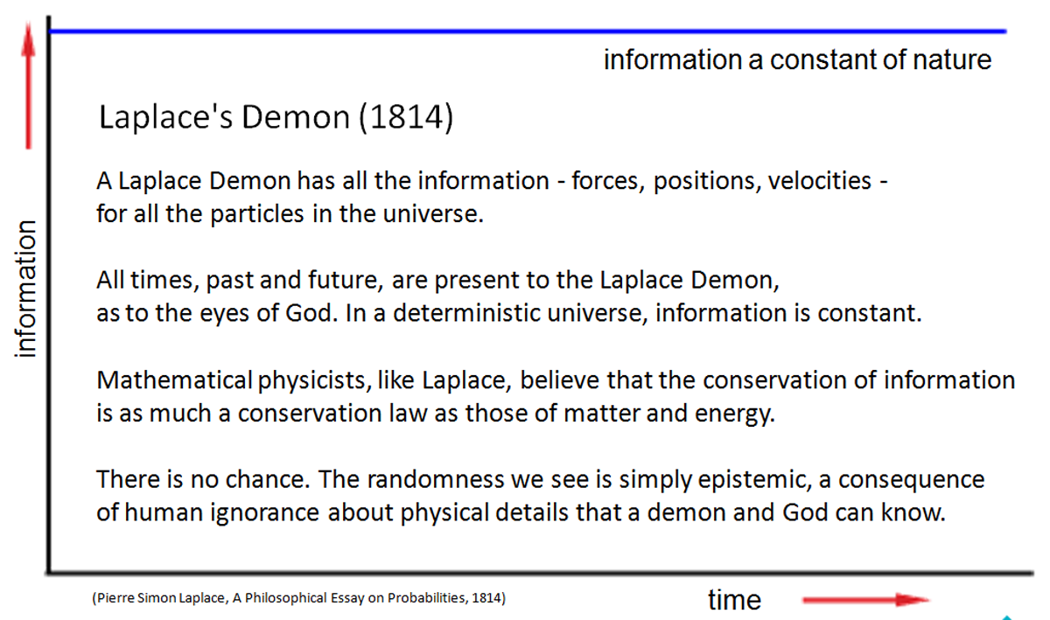
But midway through the 19th century, Lord Kelvin (William Thomson) realized that the newly discovered second law of thermodynamics required that information could not be constant, but would be destroyed as the entropy (disorder) increased. Hermann Helmholtz described this as the heat death of the universe.

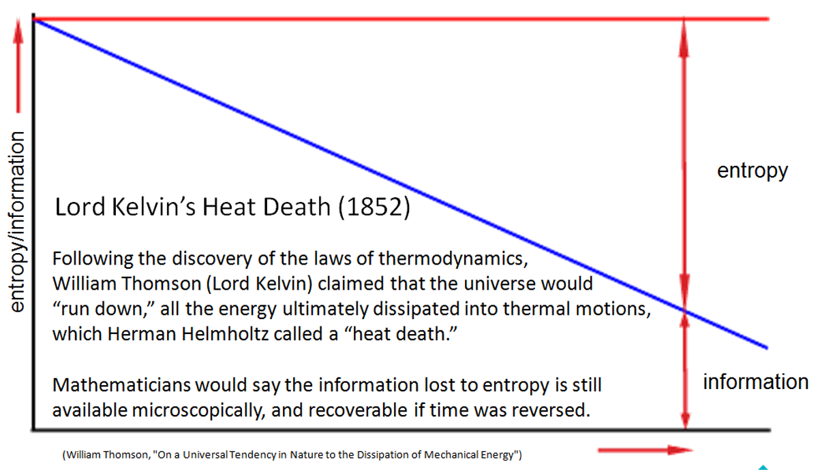

Kelvin’s claim would be correct if the universe were a closed system. But in our open and expanding universe, David Layzer showed that the maximum possible entropy is increasing faster than the actual entropy. The difference between maximum possible entropy and the current entropy is called negative entropy, opening the possibility for complex and stable information structures.
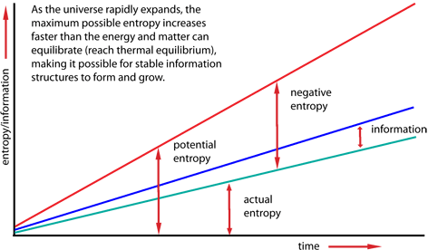
Despite the second law of thermodynamics, stable and lawlike information structures evolved out of the chaos, first, in the form of microscopic particulate matter – quarks, baryons, nuclei, and electrons, then later, under the influence of gravitation – macroscopic galaxies, stars, and planets. Every new information structure reduces the entropy locally, so the second law requires an equal (or generally much greater) amount of entropy to be carried away. Without the expansion of the universe, this would be impossible.
Whether the newly formed stable structure is a baryon or a planet, the new "bits" of information can be regarded as physical "measurements" that involve the collapse of quantum mechanical wave functions. Gunter Ludwig and Rolf Landauer showed that any such measurement that increases the number of information bits must involve a compensating increase in the entropy or randomness elsewhere. For Ludwig, it was in the measurement apparatus. For Landauer, it was the energy dissipated by a computer's power supplies.
Because of the “law of large numbers” in statistics, and the correspondence principle of quantum mechanics (which says that quantum physics approaches classical physics for large quantum numbers), the Newtonian laws of classical mechanics, discovered in the stable and regular motions of the planetary orbits, are “adequately determined.” This is despite the residue of real originary chaos in many parts of the universe, especially in the quantum-mechanical microcosmos. The effects of quantum indeterminacy can thus normally be ignored in the macroscopic world.
Randomness in biology, on the other hand, plays a central role, in the evolution of species and in the life strategies of many organisms, not only animals. (Darwin was circumspect and cautious about "mere chance," because in his time chance still evoked strong atheistic sentiments.)
For example, plants distribute their seeds to remote locations taking advantage of random winds. Immobile fruit trees drop their fruit where it can be eaten by mobile animals, which carry the indigestible seeds to new locations and deposit them along with nourishing manure as fertilizer.
In animals, Heisenberg cites the bacterium Escherichia coli. These tiny organisms are equipped with sensors and motion capability that let them make two-stage decisions about which way to go. They can move in the direction of nutrients and away from toxic chemicals. They do this with tiny flagella in their tails that rotate in two directions. Flagella rotating clockwise cause the bacterium to tumble and face random new directions. When the flagella rotate counter-clockwise, the bacterium moves forward and sensory receptors on the bacterium surface detect gradients of chemicals and temperatures. If the gradient indicates “food ahead,” or perhaps “danger behind,” the bacterium continues straight ahead. The lawlike decision to go forward is an adequately determined evaluation of sensors along the bacterium’s body. If the sensed gradients are unsuitable, the flagella reverse and the bacterium again tumbles.
Inside animals, immune systems recruit randomness to discover antibodies for invading antigens. The white blood cells have evolved a powerful strategy to discover unique information in the antigen. What they have done is evolve a "re-sequencing" capability. Using the same gene splicing techniques that biologists have now developed to insert characteristics from one organism into another, the white blood cells have a very-high-speed process that shuffles genes around at random. They cut genes out of one location and splice them at random in other locations. This combinatorial diversity provides a variation in the gene pool like the Darwinian mutations that drive species evolution. The immune system gets even more random. It has a lower-level diversity generator that randomly scrambles the individual nucleotides at the junctions between genes. The splicing of genes is randomly done with errors that add or subtract nucleotides, creating what is called junctional diversity. Once antibodies are found bind to the antigen successfully, the immune system then generates large numbers of them in an adequately determined production process.
We see that even the lowest forms of animal can recruit randomness to serve their teleonomic purposes. Now Ernst Mayr has shown that evolution is conservative, reusing existing mechanisms rather than inventing new ones. So what Mayr calls the “two-step” process of Darwinian evolution itself may have become a feature of living organisms up to higher animals and humans.
The mind’s “two-stage” ability to be creative and free is likely evolved indirectly from Mayr's "two-step" process and then directly from the combination of random and lawlike behavior in the lower animals. Free will is therefore not an ad hoc development in humans, as many philosophers (especially theologians) have thought. It is a normal biological property, not a gift of God or inexplicable mystery.
Evolving Levels of Selection
Getting from behavioral freedom in the lower animals to free will in humans has primarily involved significant changes in the complexity of the second stage – the selection process.
Although randomness may at all levels have the same source in chaotic thermal and quantal noise, we can note that the selection process itself has significantly evolved. So we can suggest different levels of selection (but note that at each level organisms use all the earlier levels as well).
Natural selection - for biological evolution, selection is reproductive success for a population.

Instinctive selection - by animals with little or no learning capability. Selection criteria are transmitted genetically.

Learned selection - for animals whose past experiences guide current choices. Selection criteria are acquired environmentally, including instruction by parents and peers.

Predictive selection - using imagination and foresight to evaluate the future consequences of choices.

Reflective and normative selection – in which conscious deliberation about cultural values influences the choice of behaviors.

We can see evolution adding more and more selection features over time that eventually become the many factors at work in the fully conscious human will.
Randomness in psychology and philosophy.
Although real chance was welcomed by at least one philosopher and psychologist of the nineteenth century (William James), since the twentieth-century discovery of real chance in the form of quantum indeterminacy by Werner Heisenberg (Martin’s father), randomness has not fared well in psychology or philosophy.
In his Gifford Lecture of 1927, Arthur Stanley Eddington had described himself as unable "to form a satisfactory conception of any kind of law or causal sequence which shall be other than deterministic." Yet just a year later, in response to Heisenberg's indeterminacy principle, Eddington revised his lectures for publication as The Nature of the Physical World. There he dramatically announced "It is a consequence of the advent of the quantum theory that physics is no longer pledged to a scheme of deterministic law," He went even farther and enthusiastically identified indeterminism with freedom of the will.
But the critical reaction of philosophers was swift. A “free electron” has nothing to do with “free will,” they complained. A quantum event in the brain, amplified to affect our reasoning, can only make our decisions random. Quantum events simply happen to us. They are not “up to us.” We are not responsible for them.
A number of prominent philosophers and scientists struggled to include quantum indeterminacy in a model of free will, including Arthur Holly Compton, Karl Popper, and Henry Margenau. But their efforts were not convincing to the philosophical community and are rarely referenced in the free will debates.
The one living philosopher who has spent his adult career trying to explain free will as involving quantum events is Robert Kane. Kane has had some significant success showing that we can be responsible for an event even if it happens indeterministically. He considers the case of a businesswoman on the way to an important meeting when she observes an assault in an alley. She has excellent (moral and humanitarian) reasons to help the victim. She has equally important (practical and self-interested) reasons to continue on and advance her career.
Kane argues that whichever way the businesswoman decides, and even if the “torn decision,” as he calls it, is undetermined as a result of neural noise, she has excellent reasons to take responsibility either way. But Kane himself has not found two-stage free will models satisfying, and other prominent libertarians like Peter van Inwagen have said that “free will remains a mystery.”
Some philosophers have been critical of Kane and argue that the agent cannot claim responsibility if the decision was at all random and thus a matter of “luck.” The idea of “moral luck” is the source of many moral paradoxes and dilemmas.,
In 1995, Alfred Mele considered a two-stage model of free will in which indeterminism (he called it incompatibilism) is confined to the early stage. The latter stage he describes as “compatibilist” (effectively and adequately determined). Mele’s model is similar to one proposed in 1978 by Daniel Dennett. Dennett’s work incorporated the earlier ideas of David Wiggins, Karl Popper, and Arthur Holly Compton.
Dennett could not endorse his own two-stage decision model because he could not imagine a plausible location for quantum events in the brain, one exquisitely timed to be of help in the decision process. How could a randomly timed event be of any help? He settled instead for computer-generated random number sequences as all that is needed in his decision-making model.
In a recent book, Mele considered the problem of free will and luck, comparing the indeterministic early stage of his model to a neural roulette wheel in the head, with a tiny neural ball whose probabilities may be high for deciding to A, but it is still luck that it did not land in the wheel segment for B. In the end Mele, like Dennett, could not endorse the two-stage model. Note that both Kane and Mele describe a choice between two given options and then look to randomness (quantum noise or a roulette wheel ball) to help with the decision.

The basic requirements for human freedom
Freedom requires the randomness of absolute chance to break the causal chain of determinism (actually pre-determinism), yet it must provide the conscious knowledge that we are adequately determined to be responsible for our choices, that our decisions and actions are "up to us."
Freedom requires some events that are not causally determined by immediately preceding events, events that are unpredictable by any agency, events involving quantum indeterminacy.
These random events can generate alternative possibilities for action. They are the source of the creativity that adds new information to the universe. Randomness is the "free" in free will.
Freedom also requires an adequately determined will that chooses or selects from those alternative possibilities. There is effectively nothing uncertain about this choice. Adequate determinism is the determination, the "will" in free will.

Adequate determinism means that randomness in our thoughts about alternative possibilities does not directly cause our actions.
Random thoughts can therefore lead to intentions, evaluations, and decisions that are adequately determined to produce actions, for which we can take moral responsibility.
Thoughts come to us freely. Actions go from us willfully.
We must admit indeterminism, but not permit it to produce random actions as Determinists mistakenly fear.
We must also limit determinism, but not eliminate it as Libertarians mistakenly think necessary.
Evaluation and careful deliberation of all the available possibilities, both ingrained habits and creative new ideas, must help us to "determine" and thus "cause" our actions.
But event acausality somewhere is a prerequisite for any kind of agent causality that is not pre-determined.
We thus define "free will" as a two-stage creative process in which a human or higher animal freely generates alternative possibilities, some caused by prior events, some uncaused, following which the possibilities are evaluated and one is "willed," i.e., selected or chosen for adequately determined reasons, motives, or desires.
How quantum noise can help free will and not compromise responsibility.
In my Cogito model of free will and creativity, randomness is not (normally) the direct cause of our actions, but rather simply the free generator of alternative possibilities for the adequately determined will to evaluate and select. (I call this noisy generator of creative ideas the "Micro Mind.")
An important additional requirement is that the adequately determined will (which I call the “Macro Mind") must have the power to invoke the Alternative Possibilities Generator (turn it on when needed and off when it is simply interfering with thought processes). For example, the bacterium in Heisenberg’s example can turn on randomness by reversing the direction of flagella rotation. This is sometimes called “downward causation.” It is not that the mind is controlling quantum events, but turning them off and on again when they are needed to produce new ideas.
The Micro Mind is different from the early stage in previous two-stage models because it does not depend on a single quantum event in the brain that gets amplified to the Macro Mind. The insoluble problem for previous two-stage models has been to explain how a random event in the brain can be timed and located - perfectly synchronized! - so as to be relevant to a specific decision. The answer is it cannot be, for the simple reason that quantum events are totally unpredictable. The mind, like all biological systems, has evolved in the presence of constant noise and is able to ignore that noise, unless the noise provides a significant competitive advantage, which it clearly does as the basis for freedom and creativity.
Rather than search for a single cause behind a decision, we assume that there are always many contributing causes for any event, and in particular for a mental decision. The Cogito model does not depend on single random events, one per decision. It recruits many random events in the brain as a result of ever-present noise, both quantum and thermal noise, that is inherent in any information storage and communication system.
In the Newell-Simon "Blackboard" mind model and Bernard Baars' "Theater of Consciousness" and "Global Workspace" models, there are always many competing possibilities for our next thought or action. Some of these possibilities may be traceable to causal chains that we ourselves did not initiate. Many possibilities are the result of genetic inheritance or environmental conditioning, for example. Some are well-established habits that are the result of what Robert Kane calls “self-forming actions (SFAs)” that happened long ago.
Each of these possibilities is the result of a sequence of events that goes back in an assumed causal chain until its beginning in an uncaused event.
If we could trace any particular sequence of events back in time it would come to one event whose major contributing cause (or causes) was itself uncaused (a causa sui).
For Aristotle, every series of causes "goes back to some starting-point (ἀρχή), which does not go back to something else. This, therefore, will be the starting-point of the fortuitous, and nothing else is the cause of its generation."
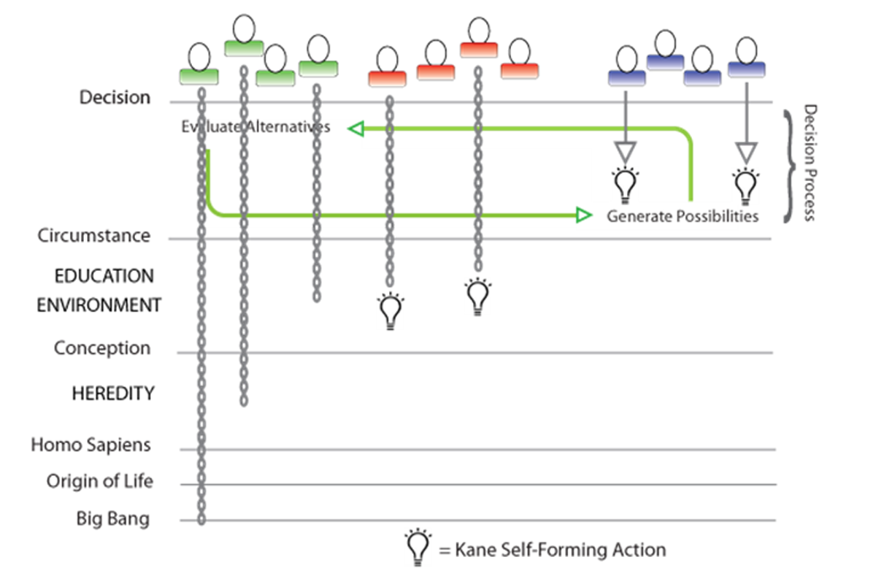
We can thus in principle assign times, or ages, to the starting points of the contributing causes of a decision. Some of these (the left-hand group in the figure) may in fact go back before the birth of an agent, hereditary causes for example. To the extent that such causes adequately determine an action, we can understand why hard determinists think that the agent has no control over such actions. (Of course, if we can opt out of a habitual action at the last moment, we retain a kind of control. We can always just say no!)
Other contributing causes may be traceable back to environmental and developmental events, perhaps education, perhaps simply life experiences, that were "character-forming" events (the middle group of events in the figure). These and hereditary causes would be present in the mind of the agent as fixed habits, with a very high probability of "adequately determining" the agent's actions in many well-understood situations.
But other contributing causes of a specific action may have been undetermined up to the very near past, even fractions of a second before an important decision and moments after the “circumstances” mistakenly thought by some compatibilists to determine the action. The causal chains for these contributing causes originate in the noisy brain (the right-hand group in the figure). They include the free generation of new alternative possibilities for thought or action during the agent's deliberations. They fit Aristotle's criteria for causes that "depend on us" (ἐφ' ἡμῖν) and originate "within us" (ἐv ἡμῖν).
Causes with these most recent starting points are the fundamental reason why an agent can do otherwise in what are essentially the same circumstances (up to the starting point of considering options).
These alternatives are likely generated from our internal knowledge of practical possibilities based on our past experience. Those that are handed up for consideration to Baars' "executive function" may be filtered to some extent by unconscious processes to be "within reason." They likely consist of random variations of past actions we have willed many times in the past.
Note that the random events that generate a new possibility need not be located in the brain itself, nor even be contemporaneous with the immediate decision. It could have been an idea first generated years ago and only now acted upon. And it could have had its origin external to the brain, in the ideas of other persons or in environmental accidents. It need only “come to mind” during deliberations, which itself is partly a matter of luck.
Note also that the evaluation and selection of one of these possibilities by the will is as deterministic and causal a process as anything that a determinist or compatibilist could ask for, consistent with our current knowledge of the physical world.
But remember that instead of strict causal determinism, the second stage offers only adequate determinism. The random origins of possibilities in the first stage provide freedom of thought and action. As long as the Micro Mind can create new alternative possibilities, we can be free.
A more detailed look at the Micro Mind
Imagine a Micro Mind with a randomly assembled "agenda" of possible things to say or to do. These are drawn from our memory of past thoughts and actions, but randomly varied by unpredictable negations, associations of a part of one idea with a part or all of another, and by substitutions of words, images, feelings, and actions drawn from our experience. In information communication terms, there is cross-talk and noise in our neural circuitry.
In a "content-addressable" information model, memories are stored based on their content - typically bundles of simultaneous images, sounds, smells, feelings, etc. So a new experience is likely to be stored in neural pathways alongside closely related past experiences. A fresh experience, or active thinking about an experience that presents a decision problem, is likely to activate nearby brain circuits, ones that have strong associations with our current circumstances. These are likely to begin firing randomly, to provide unpredictable raw material for actionable possibilities.
The strong feeling that sometimes "we don't know what we think until we hear what we say" reflects our capability for original and creative thoughts, different from anything we have consciously learned or thought before. A new idea may be something as simple as substituting a synonymous word, or more complex replacements with associated words (metonyms) or wild leaps of fancy (metaphor) are examples of building unpredictable thoughts. Picturing ourselves doing something we have seen others do, from "monkey see, monkey do" childhood mimicry to adult imitations, is a source for action items on the agenda, with the random element as simple as if and when we choose to do them.
But how exactly is the required randomness recruited to build these alternative possible thoughts and actions?
Some critics argue that brain structures are too large to be affected at all by quantum events. But there is little doubt that the brain has evolved to the point where it can access quantum phenomena. The evolutionary advantage for the mind is freedom and creativity. Biophysics tells us the eye can detect a single quantum of light (a photon), and the nose can smell a single molecule. It seems clear that the brain has evolved to the quantum limit.
If the Micro Mind is a random generator of frequently outlandish and absurd possibilities, the complementary Macro Mind is a macroscopic structure so large that quantum effects are negligible. It is the critical apparatus that makes adequately determined decisions based on our character and values.
Note that information about our character and values is probably stored in the same noise-susceptible neural circuits of our brain cortex. Macro Mind and Micro Mind are not necessarily in different locations in the brain. Instead, their difference is probably the consequence of different information processing methods. The Macro Mind must suppress the noise when it makes an adequately determined decision. But it also can turn on the sensitivity to noise in the Micro Mind when new possibilities are needed.
Normally noise is the enemy of information, but it can be the friend of freedom and creativity.
The Macro Mind has very likely evolved to add enough redundancy, perhaps even error detection and correction, to reduce the noise to levels required for an adequate determinism. This means that our decisions are in principle predictable, given knowledge of all our past actions and given the randomly generated possibilities in the instant before decision. However, only we know the contents of our minds. New possibilities exist only within our minds. So other persons could not predict our actions, and until neuroscientists can resolve the finest details of information storage in our brains, they too could not predict our thoughts and decisions.
The Cogito model accounts not just for freedom but for creativity, original thoughts and ideas never before expressed. Unique and new information may come into the world with each new thought and action. We are the originators of the new information, the authors of our lives, and in this respect we are co-creators of our universe.
Biologists will note that the Micro Mind corresponds to random variation in the gene pool (often the direct result of quantum accidents). The Macro Mind corresponds to natural selection by highly determined organisms. Karl Popper may have been the first to point this out.
Psychologists will see the resemblance of Micro Mind and Macro Mind to the Freudian id and super-ego (das Ess und das Über-ich).
The Cogito model accounts quantitatively for the concept of wisdom. The greater the amount of knowledge and experience, the more likely that the random Agenda will contain more useful and "intelligent" thoughts and actions as alternative possibilities. It also implies that an educated mind is "more free" because it can generate a wider Agenda and options for action. It suggests that "narrow" and "closed" minds may simply be lacking the capabilities of the Micro Mind. And if the Macro Mind were weak, it might point to the high correlation between creativity and madness suggested by a Micro Mind out of control, or it might be an indicator for Aristotle’s “weakness of will” (akrasia).
Philosophers of mind, whether determinist or compatibilist, should recognize this Macro Mind as everything they say is needed to make a carefully reasoned and responsible free choice. But now our choices include self-generated random possibilities for thought and action that no external agent can predict. Thus the choice of the will and the resulting willed action are unpredictable. The origin of the chosen causal chain is entirely within the agent, a condition noted first by Aristotle for voluntary action, the causes are "in us" (ἐν ἡμῖν).
The combination of microscopic randomness and macroscopic determinism in our Cogito model for human freedom means it is both unpredictable and yet fully responsible for its willed actions. Chance never leads directly to - never directly "causes" - an action.
Chance only provides the variety of alternative possibilities, each the possible start of a new causal chain, from which the deterministic judgment can choose an alternative that is consistent with our character and values. Our will is adequately determined and in control of our actions.
Decisions are not single mental events, but a multi-step, even continuous, process.
The Cogito Model is not limited to a single stage of generating alternative possibilities followed by a single stage of determination by the will.
It is better understood as a continuous process of possibilities generation by the Micro Mind (parts of the brain that leave themselves open to noise) and adequately determined choices made from time to time by the Macro Mind (the same brain parts, perhaps, but now averaging over and filtering out the noisiness that might otherwise make the determination random).
In particular, note that a special kind of decision might occur when the Macro Mind finds that none of the current options are good enough for the agent's character and values to approve. The Macro Mind then might figuratively say to the Micro Mind, "Think again!"
Many philosophers have puzzled how an agent could do otherwise in exactly the same circumstances. Since humans are intelligent organisms, and given the myriad of possible circumstances, it is impossible that an agent is ever in exactly the same circumstances. The agent's memory (stored information) of earlier similar circumstances guarantees that.
But given the "laws of nature" and the "fixed past" just before a decision, philosophers wonder how a free agent can have any possible alternatives. This is partly because they imagine a timeline for the decision that shrinks the decision process to a single moment.


Collapsing the decision to a single moment between the closed fixed past and the open ambiguous future makes it difficult to see the free thoughts of the mind followed by the willed and adequately determined action of the body.
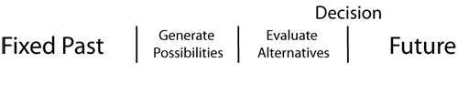
This view still makes an artificial separation between Micro Mind creative randomness and Macro Mind deliberative evaluation. These two capabilities of the mind can be going on at the same time. That can be visualized by the occasional decision to go back and think again, when the available alternatives are not good enough to satisfy the demands of the agent's character and values.
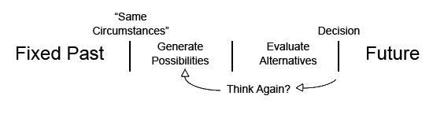

Note that the two-stage model explains how an agent can be in exactly the "same circumstances," and given the fixed past and the laws of nature, the agent can nevertheless act differently, that is to say, choose to do otherwise. This is because the decision is the end point of a temporal process that begins with those "same" circumstances. The decision-making process is not an instant in time.
Note also that the decision is not determined as soon as possibilities are generated and the alternatives evaluated. The agent may decide that none of the options is good enough and, time permitting, go back to "think again," to generate more possibilities.
Our thoughts are free and often appear to come to us. Our actions are adequately determined for moral responsibility and appear to come from us. They are up to us (Aristotle's ἐφ' ἡμῖν).
What then are the sources of alternative possibilities? To what extent are they our creations? We can distinguish three important sources, all of them capable of producing indeterministic options for thoughts and actions. Two come in from outside the mind, the third is internal.
The first source is the external world that arrives through our perceptions. It is perhaps the major driving force in our lives, constantly requiring our conscious attention. Indeed, consciousness can be understood in large part as the exchange of actionable information between organism and environment. Although the indeterministic origin of such ideas is outside us, we can take full responsibility for them if they influence our adequately determined willed actions.
The second source of options is other persons. The unique human ability to communicate information means that alternative possibilities for our actions are being generated by our reactions to other minds.
Finally, and most importantly, the Micro Mind generates possibilities internally. These are the possibilities that truly originate within us (Aristotle's ἐν ἡμῖν). In the Cogito model, the agent is a creative source, the author and originator of her ideas.

Where does the Cogito Model fit in current Free Will debates?
Recent debate on the free will problem uses a taxonomy of positions that has caused a great deal of confusion, partly logical but mostly linguistic. Let's take a quick look at the terminology.

At the top level, there are two mutually exclusive positions, Determinism and Indeterminism.

Under Determinism, two more positions conflict, Compatibilism and Incompatibilism.

And under Indeterminism, Robert Kane in his Oxford Handbook of Free Will distinguishes three positions recently taken by Libertarians - Non-Causal, Agent-Causal, and Event-Causal.
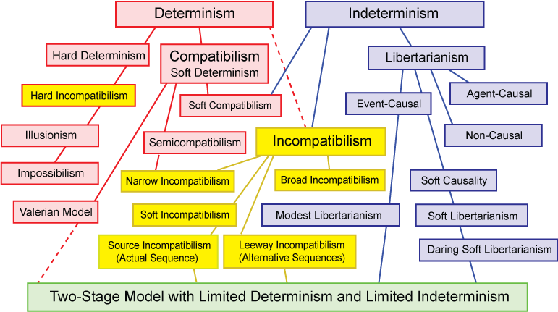
Instead of directly discussing models for free will, the debate is conducted indirectly.

Is determinism true? This is perhaps the most frequently asked question. The answer, at least in the physical world, is now well known. Determinism is not "true." The physical world contains quantum randomness - absolute chance.

Is free will compatible with determinism? This is also a frequently asked question. Most philosophers answer yes and describe themselves as compatibilists. Many compatibilists accept quantum mechanical indeterminism, but they argue that if determinism were true, we would still have the traditional compatibilist freedom of action that Hume argued for, as long as our actions were not coerced.

Why do most philosophers say they are compatibilists? Given the stark, but false, choice between determinism and indeterminism, reasonable thinkers choose determinism so that our decisions are causally connected to our reasons and values.

But chance does not mean that every event is completely undetermined and uncaused. And it does not mean that chance is the direct cause of our actions, that our actions must be random.

Nevertheless, the typical argument of determinists and compatibilists is that if our actions had random causes (anywhere earlier in the causal chain), we could not be morally responsible (excepting Robert Kane’s “torn decisions”).

To avoid the obvious difficulty for their position, some compatibilist philosophers simply deny the reality of chance. They hope that something will be found wrong with quantum mechanical indeterminism (like David Bohm’s “hidden variables”). Chance is unintelligible, they say, and thus there is no intelligible account of libertarian free will. Some dismiss free will (as many philosophers have denied chance) as an illusion.

Back in 1884, William James distinguished between Hard Determinist and Soft Determinists. The latter were what we now call Compatibilists.

Recently, professional philosophers specializing in free will and moral responsibility have staked out nuanced versions of the familiar positions with new jargon, like broad and narrow incompatibilism, semicompatibilism, hard incompatibilism, impossibilism, and illusionism.

Awkwardly, the incompatibilist position includes both "hard" determinists, who deny free will, and libertarians, who deny determinism, making the taxonomy very messy.

Broad incompatibilists think both free will and moral responsibility are incompatible with determinism. Narrow incompatibilists think free will is not compatible, but moral responsibility is compatible with determinism.
Semicompatibilists (cf. John Martin Fischer) are narrow compatibilists who are agnostic about free will and determinism but claim that moral responsibility is compatible with determinism.
Hard incompatibilists (cf. Derk Pereboom) think both free will and moral responsibility are not compatible with determinism.

Illusionists (cf. Saul Smilansky) are incompatibilists who say free will is an illusion. Some call themselves Impossibilists (cf. Galen Strawson).

Soft Incompatibilists (cf. Bob Doyle) think both free will and moral responsibility are incompatible with strict pre-determinism, but both are compatible with an adequate determinism.

Soft Causalists are event-causalists who accept causality but admit some unpredictable events that are causa sui and which start new causal chains.

Soft Libertarians (and Daring Soft Libertarians) admit some indeterminism, but only in what Fischer calls the Actual Sequence. It does not create Alternative Possibilities.

Modest Libertarianism (Al Mele) and Dan Dennett’s Valerian Model are two-stage models, similar to our Cogito Model.

Some of those who accept that indeterminism is the case, at least in the microphysical world, nevertheless deny that chance and quantum randomness can be important for free will. Oddly, this includes agent-causalists, who postulate a non-physical origin for causes (like reasons in the agent's mind), and non-causalists, who claim volitions and intentions are simply uncaused.

For the "event-causal" theorists of free will, we can distinguish six increasingly sophisticated attitudes toward the role of chance and indeterminism. "Event-causal" theorists embrace the first two, but very few thinkers, if any, appear to have considered all six essential requirements for chance to contribute to libertarian free will.
- Chance exists in the universe. Quantum mechanics is correct. Indeterminism is true, etc.
- Chance is necessary for free will. It breaks the causal chain of pre-determinism.
- Chance does not directly cause our actions. We can only be responsible for random actions if we flip a coin and claim responsibility “either way.”
- Chance can only generate random (unpredictable) alternative possibilities for action or thought. The choice or selection of one action must be adequately determined, so that we can take responsibility. And once we choose, the connection between mind/brain and motor control must be adequately determined to see that "our will be done."
- Chance, in the form of noise, both quantum and thermal, must be ever present. The naive model of a single random microscopic quantum event, amplified to affect the macroscopic brain, never made sense. Under what ad hoc circumstances, at what time, at what place in the brain, would it occur to influence a decision?
- Chance must be overcome or suppressed by the adequately determined will when it decides to act, de-liberating the prior free options that "one could have done."
Where then does the Cogito model fit in this complex taxonomy of positions? The Cogito Model is Indeterminist, Libertarian, Incompatibilist, Event-Causal, and Soft-Causal. Like Dan Dennett’s Valerian Model and Al Mele’s Modest Libertarianism, it is in the Two-Stage Models at the bottom of the taxonomy. Despite this position, we hope it might appeal to Compatibilists and even Agent Causalists.

How does the Cogito Model improve on other recent free-will views?
The two-stage Cogito model lies between the work of Libertarians and Compatibilists.
The leading Libertarian model is that of Robert Kane and his followers Laura Waddell Ekstrom and Mark Balaguer. They and Kane's critic Richard Double have all reached for the dream of genuine indeterminacy “centered” in the "moment of choice," while nevertheless achieving agential control over actions.
Kane calls it “dual voluntary control” when an agent has good reasons for deciding either way in a “torn” decision. So the choice can be random and yet the agent still can feel responsible. We accept Kane’s clever argument for responsibility “either way.” But it seems confusing to describe this as “control” at the moment of choice when the final choice is avowedly random, and Kane’s critics have strongly objected.
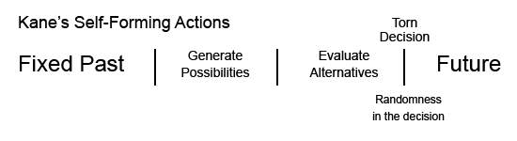
Double started out trying to justify three Kane conditions for free will - control, rationality, and dual/plural alternative possibilities that allow the agent to choose otherwise in exactly the same circumstances.
But in the end Double concluded that these three conditions could not be met simultaneously by Kane's model and said so in his 1990 book The Non-Reality of Free Will. To be sure, Double may simply share the goal of Impossibilists like Galen Strawson, or Hard Incompatibilists like Derk Pereboom, or Illusionists like Saul Smilansky. All these share a goal to deny moral responsibility in order to eliminate moral "desert" and retributive punishment.
Let’s see how the Cogito model can improve on Kane’s example of the businesswoman mentioned above. Recall that she is “torn” between helping the victim in the alley and continuing to her important business meeting. Before she decides (randomly) between the given choices, she can activate her alternative possibilities generator and the Micro Mind might come up with additional alternative possibilities. She might for example continue on to her meeting but get out her cell phone to report the crime and call for assistance. On her way she might tell any passersby to go to the victim’s aid. Note that these creative new options can “come to her” up to and even beyond the moment of choice in this case (she is on her way to the office).
So the Cogito model with the alternative possibilities generator appears to provide real freedom beyond earlier two-stage models that Kane properly found unacceptable.
The leading thinkers to have proposed but not endorsed a two-stage model are the compatibilist Daniel Dennett and the agnostic Albert Mele. Neither of them could see how quantum events could provide an intelligible explanation. But they both saw benefits. Dennett said his decision model could “give libertarians what they say they want.” He was right, and it is surprising that more libertarians did not adopt Dennett’s model and try to improve upon it, perhaps finding the proper role for quantum events, as the Cogito model has now done.
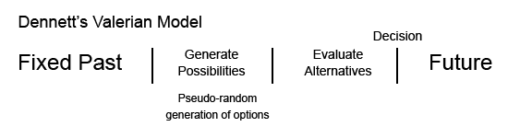
Daniel Dennett's Valerian Model of decision making adds randomness in the first-stage generation of considerations, but he believes that pseudo-randomness (the kind generated by computer algorithms) is random enough.
Dennett sees no need for genuine irreducible quantum randomness in the mind, although he does not deny that the world contains genuine quantum indeterminacy. He also does not think, as does Jacques Monod, for example, that quantum indeterminacy is necessary for biological evolution. The evolved virtual creatures of artificial life programs demonstrate for Dennett that biological evolution is an algorithmic process.
Dennett says of the second stage that "after a certain amount of deliberation, I say to myself: 'That's enough. I've considered this matter enough and now I'm going to act,' in the full knowledge that I could have considered further, in the full knowledge that the eventualities may prove that I decided in error, but with the acceptance of responsibility in any case."
He says that "this model...provides some account of our important intuition that we are the authors of our moral decisions."
Alfred Mele’s “agnostic autonomism” and “modest libertarianism” were designed to take the best parts of libertarian and compatibilist positions, and make them defensible whether determinism or indeterminism was “true.”
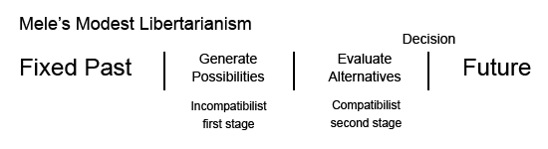
Mele's modest libertarianism provides what he calls an "incompatibilist" first stage (he means indeterminist) and a compatibilist second stage (he means determinist).
Mele does not (as does Kane? and many philosophers since a mistaken reading of R. E. Hobart's 1934 Mind article) think this determination of the will would imply pre-determinism.
Mele locates the randomness in the incompatibilist first stage of his two-stage model, where alternative possibilities are generated.
Mele's model is similar to Dennett's, but does not argue for pseudo-random (deterministic) randomness. However, because Mele is agnostic about the truth of determinism and indeterminism, he does not discuss the operation of quantum randomness explicitly.
Like Mele’s models, the Cogito model is less "free" than extreme libertarian views, but more responsible. As Mele has said, in the second stage, the will is as adequately determined as any compatibilist could desire.
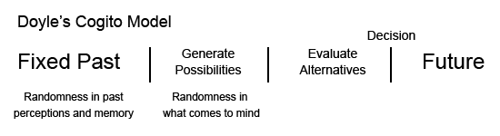
The Cogito model is also less "determined" than some extreme Compatibilist views, because it is not predetermined in the sense of a causal chain back to the universe origin. But it is more creative than standard compatibilist views.
It provides for determination of the will by the agent’s reasons, motives, feelings, and desires. But it allows the limited indeterminism needed for the generation of new ideas that allow the agent to be the originator and author of her life.
The Cogito Model locates randomness not only in the generation of alternative possibilities, but also in past perceptions and imperfect memories that may have involved quantum indeterminacy.
The brain/mind is an information-processing system susceptible to quantum quantum and thermal noise. Errors are unavoidable in the recording and reproducing of experiences. These errors break the causal chain of pre-determinism back before an agent's birth. They are the source of novelty and creativity. They make us originators and authors of our lives.
The brain very likely also has access to "built-in" quantum randomness that it can turn on and off during the generation of possibilities. It has evolved to the quantum limit, able to see a single photon and smell a single molecule. So if the mind finds an advantage in quantum indeterminacy, it can recruit it when it proves useful, and suppress it when it's a problem.
This suggests that randomness might sometimes not be suppressed during the otherwise determinative evaluation of alternatives and final decisions. While very unlikely, such randomness might show up as occasional irrationality or "weakness of will." And of course, it would support Bob Kane's "torn decisions" and SFAs.
David Hume reconciled freedom with determinism. Can the Cogito model reconcile free will with indeterminism?
Might compatibilists find this a satisfactory model for a more comprehensive compatibilism, one compatible both with adequate determinism and with indeterminism that is limited to the generation of alternative possibilities?
Of course the model is still incompatible with pre-determinism, and with indeterminism after or centered at the moment of choice (again excepting Kane's cases of "torn decisions").
The Cogito model is perhaps less "event-causal" and more "agent causal," because the agent has creative powers during the extended "moment of choice." These are the kind of powers sought by agent-causalist libertarians like Roderick Chisholm, Richard Taylor, and Keith Lehrer. These philosophers called for an absolute freedom, even from causes like reasons, motives, feelings, and desires. This shocked compatibilists at the time. Could such agent causalists be satisfied with the agent’s ability to generate totally unconstrained new ideas right up to and including the “moment of choice,” ideas that are not caused by anything prior to their generation?
Nothing in the events of the "fixed past" (and the laws of nature, as compatibilists like to say) up to the "moment of choice" predetermines the agent's decision. Because it generates new alternative possibilities, the Cogito model lets the agent choose otherwise in exactly the same circumstances that obtained before the “moment of choice.” Kane calls this the “Indeterminist Condition,” he says “the agent should be able to act and act otherwise (choose different possible futures), given the same past circumstances and laws of nature.
This ability to do otherwise is often considered the most extreme requirement for libertarianism. The Cogito model now provides a credible explanation for this very important ability to do otherwise in exactly the same circumstances before the decision process began.
The Problem of Luck
Since the Cogito model embraces indeterminism as the source of alternative possibilities for action, it recognizes the irreducible nature of luck in the world. The existence of real chance makes luck a major source of moral paradoxes and dilemmas, as developed by Thomas Nagel in his 1979 essay “Moral Luck” and the 1981 book of the same name by Bernard Williams. Alfred Mele’s 2006 book Free Will and Luck explores the connection with free will. He says
“Agents' control is the yardstick by which the bearing of luck on their freedom and moral responsibility is measured. When luck (good or bad) is problematic, that is because it seems significantly to impede agents' control over themselves or to highlight important gaps or shortcomings in such control.” (p.8)
We agree with Mele. It is essential that the second stage of a willed decision is adequately determined and proof of agential control. This establishes the agent’s responsibility or accountability. But moral responsibility is a more difficult question, one for moral philosophers to answer. Randomness or luck in the earlier stage of possibilities generation may raise valid questions of moral responsibility and the appropriateness of praise or blame, reward or punishment. But such luck does not invalidate free will, as chance is essential to the generation of alternative possibilities.
Separating Free Will from Moral Responsibility
From its earliest beginnings, the problem of "free will" has been intimately connected with the question of moral responsibility. Most ancient and modern thinkers on the problem have been trying to show that we humans have control over our decisions, that our actions "depend on us", and that they are not pre-determined by fate, by arbitrary gods, by logical necessity, or by a physical causal determinism.
But there are good analytic reasons to separate free will from moral responsibility, at least since 1962 when Peter Strawson argued that whatever the deep metaphysical truth on the issues of determinism and free will, people would not give up talking about and feeling moral responsibility - praise and blame, guilt and pride, crime and punishment, gratitude, resentment, and forgiveness.
Philosophers have asked whether free will and moral responsibility are limited to humans, and at what age children suddenly become free. We can separately answer the question of freedom with a scientific answer. All animals have freedom of behavior. Their actions are not pre-determined, although many actions are adequately determined by genetic and environmental factors, by physical limitations and external circumstances, and, most importantly, by their intentions.
Moral responsibility is less a scientific question than it is a social and cultural question – what is right and wrong? It is not free will that is acquired in human development, it is the competence to reflect on one’s behavior in the light of social norms. It is moral responsibility that is acquired, not freedom.
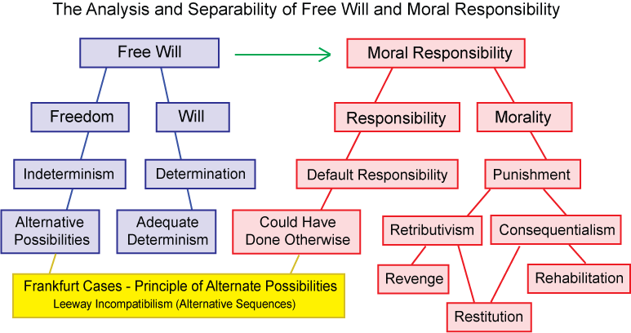

The Separation of "Free" from "Will"
"Free Will" - in scare quotes - refers to the common but mistaken notion that the adjective "free" modifies the concept "will." In particular, it indicates that the element of chance, one of the two requirements for free will, is present in the determination of the will itself. In two-stage models of free will, the randomness is limited to the generation of alternative possibilities in the first stage. The second stage of evaluation and decision is adequately determined.
The Separation of "Moral" from "Responsibility"

Responsibility for a willed action can be ascribed to an agent because the "adequately" determined will has started a new causal chain that includes the action and its foreseeable consequences. But responsibility is not the same as moral responsibility. It is merely a prerequisite for moral responsibility. Responsibility is similar to accountability. Just as an action can be said to be a cause of its consequences, so the agent can be held accountable for the action. But different moral codes, which are the concern of ethicists, may have different degrees of moral responsibility for the same actions and its consequences.

The Separation of "Free Will" from "Moral Responsibility"
The question of the existence of "free will" is an empirical and factual question about the nature of the mind. It does not depend on the existence of "moral responsibility," which is a question for ethics. John Martin Fischer says that some philosophers do not distinguish between freedom and moral responsibility. For such philosophers, "freedom" refers to whatever conditions are involved in choosing or acting in such a way as to be morally responsible. But moral decisions are not the only free decisions.
The Separation of "Free Will and Moral Responsibility" from “Punishment”
Liberal and humanitarian thinkers who see that much retributive punishment is cruel and unproductive should not try to argue that punishment is not "deserved" by arguing that free will does not exist.
They have excellent reasons for preferring rehabilitation and education to vengeance. And humane society long ago substituted restitution (“an eye for an eye”) for brutal revenge. The balance and fairness that justice demands for unacceptable behavior is properly described as one’s “deserts.”
Whether man - and higher animals too - have free will is an empirical scientific question. Whether they have moral responsibility is a social and cultural question.
When well-meaning thinkers conflate free will with moral responsibility, then use spurious arguments to deny free will in order to deny its equivalent, moral responsibility, for the sole purpose of eliminating punishment, it may very well be fine humanism, but it is poor philosophy, and terrible science.
Dennett’s Indeterminism Challenge
Dan Dennett challenged me to give reasons why quantum indeterminacy is better than computer pseudo-randomness. Dennett does not deny quantum indeterminacy. He just doubts that quantum randomness is necessary for free will. I think it breaks the causal chain of pre-determinism.
Quantum randomness has been available to evolving species for billions of years before pseudo-randomness emerges with humans. But Dennett does not think, as does Jacques Monod, for example, that quantum indeterminacy is necessary for biological evolution. The evolved virtual creatures of artificial life programs demonstrate for Dennett that biological evolution is an algorithmic process.
Here I propose five cases where quantum chance is critically important and better than pseudo-randomness. They all share a basic insight from information physics. Whenever a stable new information structure is created, two things must happen. The first is a collapse of the quantum wave function that allows one or more particles to combine in the new structure. The second is the transfer away from the structure to the cosmic background of the entropy required by the second law of thermodynamics to balance the local increase in negative entropy (information).
Laplace’s Demon
Indeterministic events are unpredictable. Consequently, if any such probabilistic events occur, as Dennett admits, Laplace’s demon cannot predict the future. Information cosmology provides a second reason why such a demon is impossible. There was little or no information at the start of the universe. There is a great deal today, and more being created every day. There is not enough information in the past to determine the present, let alone completely determine the future. Creating future information requires quantum events, which are inherently indeterministic. The future is only probable, though it may be "adequately determined." Since there is not enough information available at any moment to comprehend all the information that will exist in the future, Laplace demons are impossible.
Intelligent Designers
Suppose that determinism is true, and that the chance driving spontaneous variation of the gene pool is merely epistemic (human ignorance), so that a deterministic algorithmic process is driving evolution. Gregory Chaitin has shown that the amount of information (and thus the true randomness) in a sequence of random numbers is no more than that in the algorithm that generates them.
This makes the process more comprehensible for a supernatural intelligent designer. And it makes the idea of an intelligent designer, deterministically controlling evolution with complete foreknowledge, more plausible. This is unfortunate.
An intelligent designer with a big enough computer could reverse engineer and alter the algorithm behind the pseudo-randomness driving evolution. This is just what genetic engineers do.
But cosmic rays, which are inherently indeterministic quantum events, damage the DNA to produce genetic mutations, variations in the gene pool. No intelligent designer could control such evolution.
So genetic engineers are intelligent designers, but they cannot control the whole of evolution.
Frankfurt Controllers
For almost fifty years, compatibilists have used Frankfurt-style Cases to show that alternative possibilities are not required for freedom of action and moral responsibility.
Bob Kane showed in 1985 that, if a choice is undetermined, the Frankfurt controller cannot tell, until the choice is made, whether the agent will do A or do otherwise. Compatibilists were begging the question by assuming a deterministic connection between a “prior sign” of a decision and the decision itself.
More fundamentally, information philosophy tells us that because chance (quantum randomness) helps generate the alternate possibilities, information about the choice does not come into the universe until the choice has been made.
Either way, the controller would have to intervene before the choice, in which case it is the controller that is responsible for the decision. Frankfurt controllers do not exist.
Dennett Eavesdroppers
I call this Dennett's Eavesdropper because, in a discussion of quantum cryptography, Dennett agrees there is a strong reason to prefer quantum randomness to pseudo-randomness for encrypting secure messages. He sees that if a pseudo-random number sequence were used, a clever eavesdropper might discover the algorithm behind it and thus be able to decode the message.
Quantum cryptography and quantum computing use the non-local properties of entangled quantum particles. Non-locality shows up when the wave-function of a two-particle system collapses and new information comes into the universe. See the Einstein-Podolsky-Rosen experiment.
Meme Makers
Richard Dawkin’s unit of cultural information has the same limits as purely physical information. Claude Shannon’s mathematical theory of the communication of information says that information is not new without probabilistic surprises. Quantum physics is the ultimate source of that probability and the possibilities that surprise us. If the result were not truly unpredictable, it would be implicitly present in the information we already have. A new meme, like Dennett’s intuition pumps, skyhooks, and cranes, would have been already predictable there in the past and not his very original creations.
Information and Free Will
The original and novel contribution to the solution of the free will problem that is central to the Cogito model is the result of an informational analysis of the problem.
Abstract information is neither matter nor energy, yet it needs matter for its concrete embodiment and energy for its communication. Information is the modern spirit, the ghost in the machine.
Every human experience is recorded in the brain as an information structure. Elements of the original experience can be reproduced when the brain retrieves the stored information and plays it back. But, as with any case of the creation storage, recall, and communication of information, errors are introduced.
Modern digital computers and digital communication systems can detect and correct those errors, but they have not been eliminated. For this reason, digital computers and their algorithms are not well suited for models of the mind. They are ideal deterministic machines.
Errors in information storage and retrieval are the result of noise, both thermal and quantal noise. This noise is the way quantum indeterminacy enters into the generation of alternative possibilities for the will to evaluate and select.
Normally noise is the enemy of information, but it can be the friend of freedom and creativity.

Neuroscience and Free Will – Libet’s Experiment

Benjamin Libet’s famous experiments are widely regarded as having established that conscious will is an illusion, starting with Libet’s own claim (mistaken, we shall argue) that the readiness potential (RP) that he observed a few hundred milliseconds before the awareness of conscious will and the consequent muscle motion, was the cause of both the will and the action. Libet proposed that the will could nevertheless be free, if there was time for it to “veto” its own prior decision, which had been caused by the RP.
But as Al Mele has shown, the experimental data do not support a causal relationship. We can see this by interpreting the rise in the RP as the early stage in the two-stage model. The brain may only be considering its alternative possibilities!

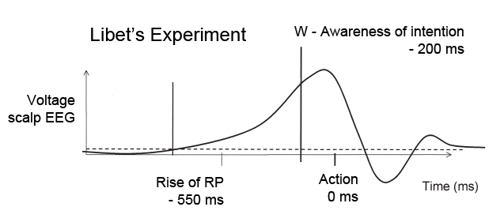
Although the abrupt and rapid decisions to flex a finger measured by Libet bear little resemblance to the kinds of two-stage deliberate decisions needed for responsibility, it seems reasonable to assume that neuronal activity might arise as the mind considers whether to flex or not to flex, when it forms the intention to flex. Roderick Chisholm argued that at least one alternative possibility always exists, we can always say no.
Libet, Haggard, Wegner, Koch and the others who say the conscious will does not cause the action, because your neurons have already made the decision, cannot prove a causal relation between RP and action. They are begging the question, assuming that a deterministic relation exists between the early stage RP and the action simply because it shows up earlier than the action (post hoc, propter hoc).
What if the early RP is just the first stage of developing options, followed by evaluating them, then deciding? In such an arbitrary choice - to flex or not flex, we should expect to see the readiness potential occasionally rise up, but then not be followed by the W point and no muscle motion. The fact that Libet reports none of these lends weight to the idea that RP and muscle motion are indeed causally related. But this is a mistake, as pointed out by Alfred Mele.
All the Libet experiments work by storing the last few seconds of data that have been collected, triggered by detecting the wrist flex itself. The equally likely cases of a rise in RP followed by no wrist flex have been systematically ignored by Libet.
This missing data would establish there is no causal connection between RP and action, only between RP and considering the alternate possibilities, to flex or not to flex, in the two-stage model of free will.

Can our solution to the free will problem reverse a negative social trend?
Ever since Hume, libertarian philosophers have expressed concerns that determinism implies a lack of moral responsibility and might, like a form of fatalism, even encourage irresponsibility.
In the past few decades, the exhaustive determinism-indeterminism standard argument against free will has been used by some philosophers to deny the existence of moral responsibility. Others have expressed the ancient concern that people who are told they have no free will may behave less responsibly. Some psychological studies have confirmed such a laxity in moral behavior. Other philosophers and psychologists have openly called for our legal and judicial systems to recognize that advances in neuroscience will show ultimately that all human action is causally predetermined, and that no one should be held responsible for crimes.
One would hope that philosophers who are skeptical about the truth of modern physics, and claim to be agnostic about the truth of determinism or indeterminism, would be more circumspect and cautious about recommending drastic and unjustifiable changes in social policies based on little or no empirical evidence.
Establishing a credible model of human freedom based on our best understanding of physics and biology, neuroscience and psychology, after millennia of fruitless philosophical debates, promises to alter this destructive social trend.
Indeed, because the higher animals share our ability to use immaterial information structures in our minds to arrive at free decisions for action, we might extend the rights and responsibilities we grant to humans to some of these animals.
Conclusion
Although the problem of free will is nearly twenty-three centuries old, it is time to acknowledge that today we have an acceptable scientific two-stage solution. About 125 years ago, William James said that we must accept absolute chance as a part of that solution, comparing the role of chance explicitly to its role in evolution that Darwin had announced a quarter-century earlier.
In this hundredth anniversary year of James’s death, it is time for recognition of his great achievement, bravely proclaimed to an audience of Harvard Divinity School students in an age when chance was still considered atheistic and an affront to God’s foreknowledge.
Seventy-five years ago, James’s most important student, Dickinson Miller, writing under the pseudonym R.E.Hobart and just a few years after quantum indeterminacy was discovered, reminded us that determination by the will was also required. Unfortunately, his work was misread by many compatibilist philosophers as requiring determinism.
Fifty years ago, A.J.Ayer and J.J.C.Smart perfected the standard logical argument against free will, that either determinism or indeterminism must be true, and that free will was impossible either way. If we are determined, we are not free. If we are undetermined, our will is random.
Just over a quarter century ago, Karl Popper, Henry Margenau, and Daniel Dennett discussed two-stage models for free will that connected quantum events to our decisions, but the general philosophical community remained determinist and compatibilist. This was despite Peter van Inwagen’s Consequence Argument that denied free will if all our actions are traceable in a causal chain to events back long before we were born. And it was despite Robert Kane’s book Free Will and Values which launched his campaign to find some intelligible way to make quantum indeterminacy the key to free will.
Now Martin Heisenberg has identified chance as generating alternative possibilities for action in the lowest animals. Evolution has no doubt conserved this ability to recruit chance, since it provides the significant biological advantage of creativity. Behavioral freedom in lower animals has evolved to become free will in higher animals and humans.
The two-stage solution of first "free" and then "will" is simple, intuitive, and the common sense view of the layperson. Our thoughts come to us freely. Our actions go from us willfully.
We can see as clearly as William James long ago that humans have a free will that cannot be denied by the sophisticated logical and linguistic debates of the “soft determinist” or "hard determinist" philosophers.
Where philosophers prefer problems that hone their students’ logical and linguistic debating skills, scientists seek solutions that can advance knowledge and educate their students about new information coming into the universe. In his finest moments, William James was both a great philosopher and a great scientist.

Notes:

Martin Heisenberg, "Is Free Will an Illusion?," Nature, 459, (May 2009): 164-165.
Daniel Wegner, The Illusion of Conscious Will (Cambridge, MA: MIT Press, 2002).
Robert O. Doyle, “Free Will: it’s a normal biological property, not a gift or a mystery," Nature, 459 (June 2009): 1052.
William James, "The Dilemma of Determinism,” The Will to Believe (New York, Dover, 1956), p. 145.
James, “Dilemma,” p.153.
William James, "Great Men, Great Thoughts, and the Environment," Atlantic Monthly 46 (October 1880): 441-459.
Others include , Henri Poincaré, Arthur Holly Compton, Karl Popper, Daniel Dennett, Henry Margenau, Robert Kane, Alfred Mele, and the author. For a full listing see http://www.informationphilosopher.com/freedom/two-stage_models.html (accessed November 15, 2010).
Lucretius, De Rerum Natura, Book 2, lines 251-62 (Cambridge, MA, Harvard, 1982). Loeb Library, W.H.D. Rouse, trans.
Cicero, De Natura Deorum, Book I, XXV, 69-70 (Cambridge, MA, Harvard, 1951). Loeb Library, H. Rackham, trans.
A. A. Long, Hellenistic Philosophy (Berkeley, U. California Press, 1986) p.149.
A. J. Ayer, Philosophical Essays, (New York, St. Martin's Press, 1954) p.275; J. J. C. Smart, "Free-Will, Praise and Blame," Mind, LXX, 279 (1961) pp.291-306. For several more examples, see http://www.informationphilosopher.com/freedom/standard_argument.html, (accessed November 18, 2010).
John Locke, Essay Concerning Human Understanding, Book II, Chapter XXI, Of Power, sections 14-21 (New York, Dover, 1959), pp.319-324
David Hume, Enquiries concerning Human Understanding, Section VII, "Of Liberty and Necessity" (Oxford, Clarendon Press, 1975), p.95
Hume, Enquiries, Section VI, Of Probability, p.56
Hume, Enquiries, Section VII, p.96.
Hume, Enquiries, Section VIII, Of Liberty and Necessity, p. 99
David Layzer, "The Arrow of Time," Scientific American 233, 6 (1975) pp.56-69.
Gunter Ludwig, "Der Messprozess (The Problem of Measurement)." Zeitschrift für Physik 135 (1953), p.483.
Rolf Landauer: "Irreversibility and heat generation in the computing process," IBM Journal of Research and Development, 5 (1961) pp. 183-191.
Heisenberg, Nature, p.165.
Bruce Alberts et al., Molecular Biology of the Cell, 4th ed. (New York, Garland Science, 2003), pp.1385-1392.
Ernst Mayr, Toward a New Philosophy of Biology, (Cambridge, MA, Harvard Belknap Press, 1988), p.150.
Arthur Stanley Eddington, The Nature of the Physical World (Ann Arbor, U. Michigan Press, 1958), p. 294.
Eddington, Nature, p.295.
L. Susan Stebbings, Philosophy and the Physicists, Chapter IX (New York, Dover, 1958) p.185.
“Up to us” or “depends on us” (ἐφ ἡμῖν ) was for the Greeks, and particularly for Aristotle, the term closest to the modern complex idea of free will, (which combines freedom and determination in an apparent internal contradiction). Aristotle and Epicurus both said it was a third thing that was neither chance nor necessity. The idea was a kind of “agent causality” that provides accountability or moral responsibility. Because our actions originate "within ourselves" (ἐν ἡμῖν), they say that as "agents" we are "causes."
Arthur Holly Compton, Science, 74, (1931) p.1911.
Karl Popper, Natural Selection and the Emergence of Mind (Cambridge, Darwin College, 1977)
Henry Margenau, Scientific Indeterminism and Human Freedom (Latrobe, PA, Archabbey Press, 1968)
Robert Kane, “Responsibility, Luck, and Chance,” Journal of Philosophy, 96, 5 (1999) p.225.
_________, A Contemporary Introduction to Free Will (New York, Oxford, 2005) p.65.
Peter van Inwagen, "Free Will Remains a Mystery," Philosophical Perspectives, 14 (2000) p.14.
Thomas Nagel, "Moral Luck," in Mortal Questions, (Cambridge, Cambridge U. Press, 1979) p.24.
Bernard Williams, Moral Luck (Cambridge, Cambridge U. Press, 1981) p.20.
Alfred Mele, Autonomous Agents (New York, Oxford, 1995) pp.212-13.
Daniel Dennett, "On Giving Libertarians What They Say They Want," Brainstorms (Montgomery, VT, Bradford Books, 1978) p.295
David Wiggins, "Towards a Reasonable Libertarianism," Essays on Freedom of Action, ed. Ted Honderich (London, Routledge & Kegan Paul, 1973) p. 33.
Alfred Mele, "A Modest Libertarian Proposal," Free Will and Luck (Oxford, Oxford U. Press, 2006) p.9.
See http://www.informationphilosopher.com/freedom/cogito (accessed March 15, 2010)
Nancey Murphy, George F.R. Ellis, and Timothy O'Connor, Downward Causation and the Neurobiology of Free Will (Springer, New York, 2009)
Allen Newell and Herbert A. Simon, Human Problem Solving (Englewood Cliffs, NJ, Prentice Hall, 1972)
Bernard Baars, In The Theater of Consciousness (New York, Oxford, 1997)
Robert Kane, Free Will and Values (Albany, SUNY Press, 1984)
Aristotle, Metaphysics, Book VI 1027b12-14 (Cambridge, MA, Harvard, 1933) Loeb Library, H. Tredennick, trans.
_______, Nichomachean Ethics, III.v.6, 1113b19-22(Cambridge, MA, Harvard, 1933) Loeb Library, H. Rackham, trans.
Karl Popper, Natural Selection and the Emergence of Mind (Cambridge, Darwin College, 1977)
Robert Kane, Oxford Handbook of Free Will (Oxford, Oxford U. Press) p.23.
John Martin Fischer, "Introduction:Responsibility and Freedom," In J. Fischer, ed., Moral Responsibility. (Ithaca, NY: Cornell, 1986)
Derk Pereboom, “Determinism al Dente,”Noûs 29 (1995), reprinted in Free Will, ed. D. Pereboom (Indianapolis, IN, Hackett, 1997), p.242
Saul Smilansky, Free Will and Illusion (Oxford, Clarendon Press, 2002)
Galen Strawson, Freedom and Belief (Oxford, Clarendon Press, 1986)
Laura Waddell Ekstrom, Free Will (Boulder, CO, Westview Press, 2000)
Mark Balaguer, Free Will as an Open Scientific Problem (Cambridge, MA, MIT Press, 2010)
Richard Double, The Non-Reality of Free Will (New York, Oxford, 1991)
Galen Strawson, “The Impossibility of Moral Responsibility,” Philosophical Studies 75/1-2 , (1994) pp.5-24.
Derk Pereboom, Living Without Free Will (Cambridge, Cambridge U. Press))
Saul Smilansky, Free Will and Illusion (Oxford, Clarendon Press, 2000)
Dennett, Brainstorms, p.286.
Mele, Autonomous Agents, p.212.
Roderick Chisholm, "Agents, Causes, and Events: The Problem of Free Will," in Agents, Causes, and Events: Essays on Indeterminism and Free Will. , ed. T. O'Connor, (Oxford, Oxford U. Press, 1995) p.95.
Richard Taylor, Action and Purpose (Englewood Cliffs, NJ, Prentice-Hall, 1966)
Keith Lehrer, "An Empirical Disproof of Determinism," Freedom and Determinism, ed. K. Lehrer (New York, Random House, 1966) p. 175.
Kane, A Contemporary Introduction to Free Will, p.38.
Mele, Free Will and Luck, p.8.
Alfred Mele, Effective Intentions: The Power of Conscious Will, (Oxford, Oxford University Press, 2009) and “Revisiting Libet’s Experiments,” Presentation at STI Experts Meeting, Barcelona, Spain, October 29, 2010.
Kathleen Vohs and Jonathan Schooler, “The Value of Believing in Free Will”, Psychological Science, 19, 1 (January 2008).
R. E. Hobart, "Free Will as Requiring Determination, and Inconceivable Without It," Mind, Vol XLIII, 169 (1934) p.2
Peter van Inwagen, An Essay on Free Will (Oxford, Clarendon Press, 1983) p.16.
Kane, Free Will and Values, p.36.

